Volume

Definition
# Source: AI Source: Provided by: [Data Path: Persons Table -> ID Column: 1, Name_En Column: Motasem Essam] -> From: [ChatGPT] on [7/20/2026]
Volume is the measure of the amount of three-dimensional space occupied or enclosed by a solid object or region.
In simple terms:
Volume measures how much space a 3D object contains or occupies.
$$\boxed{\text{Volume}=\text{Measure of 3D Space}}$$
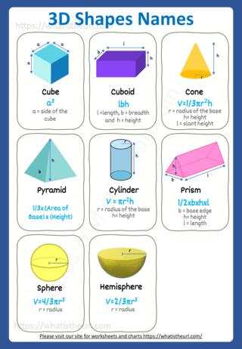
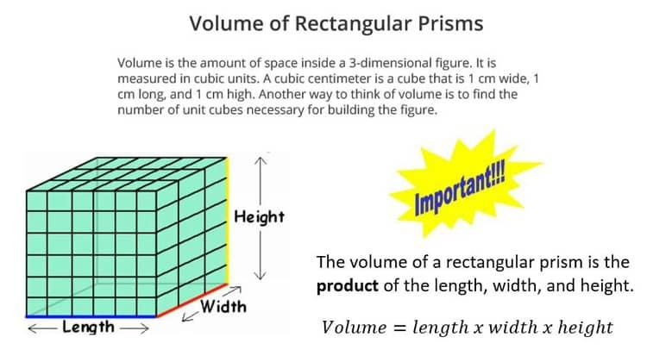
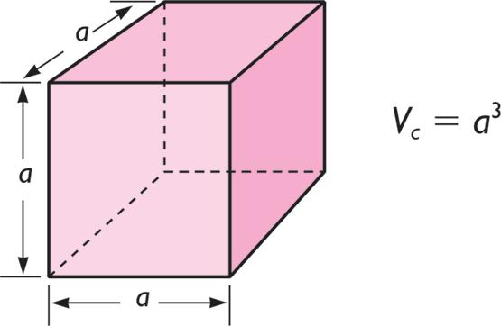
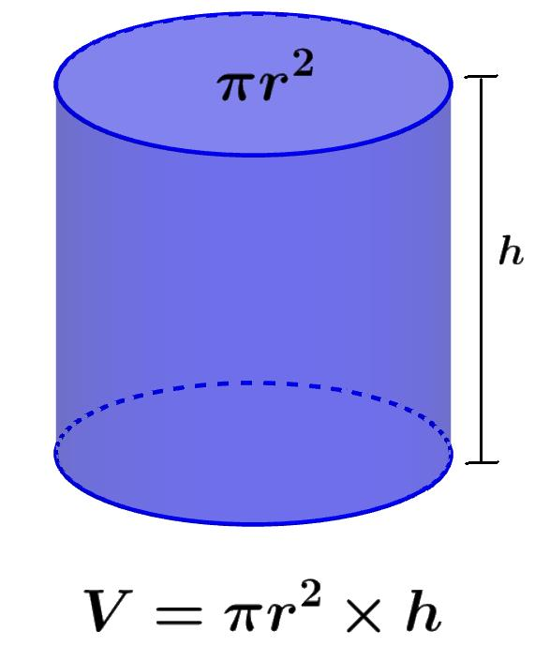
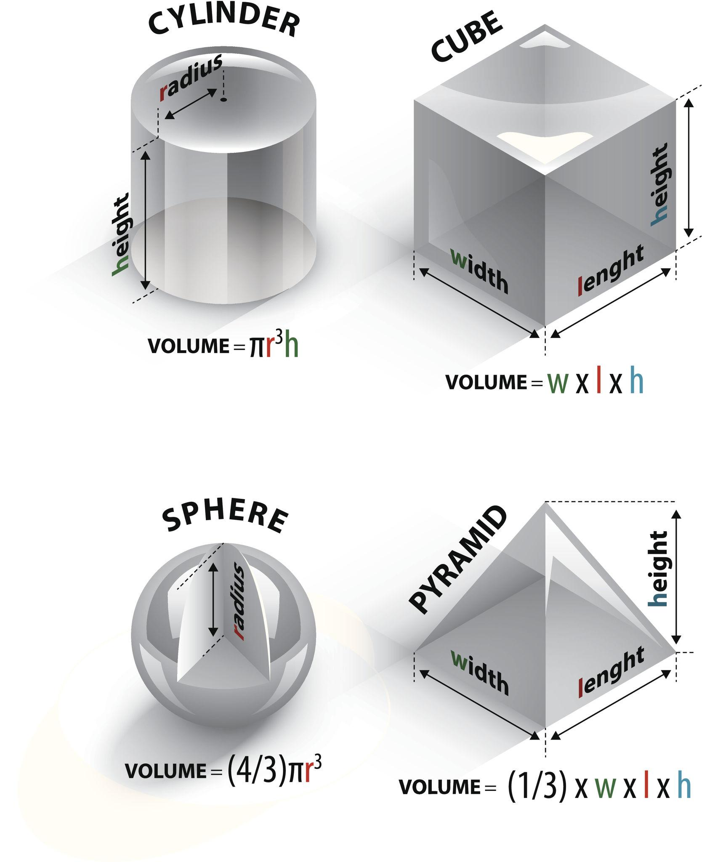
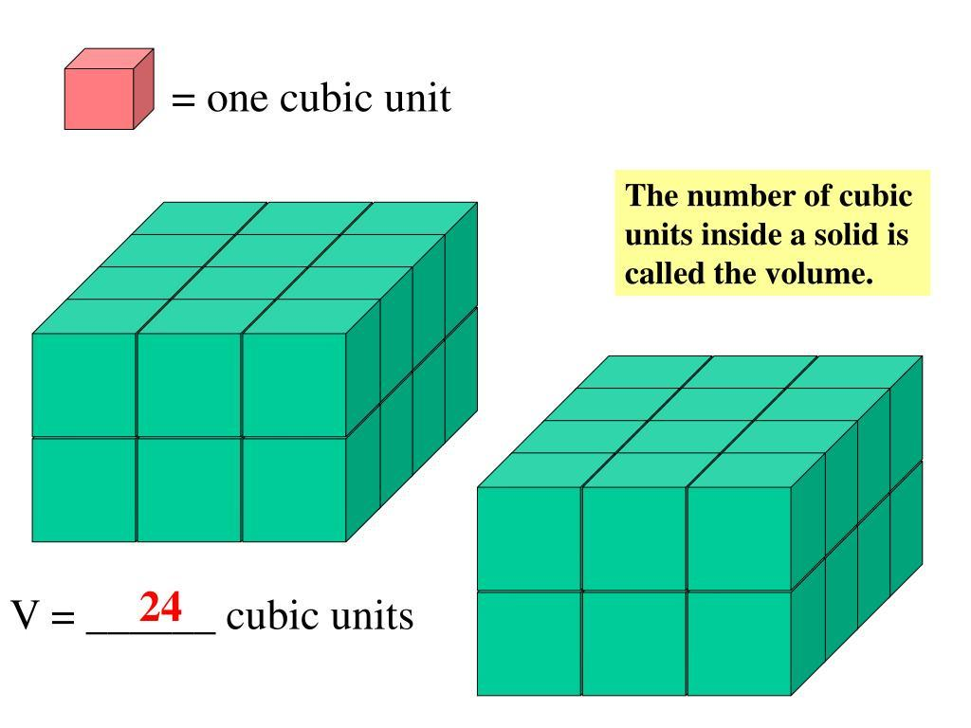
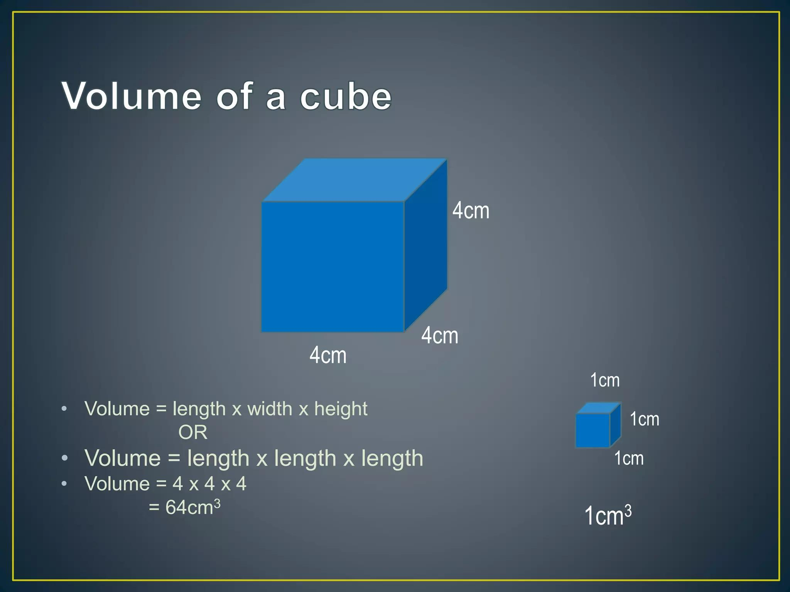
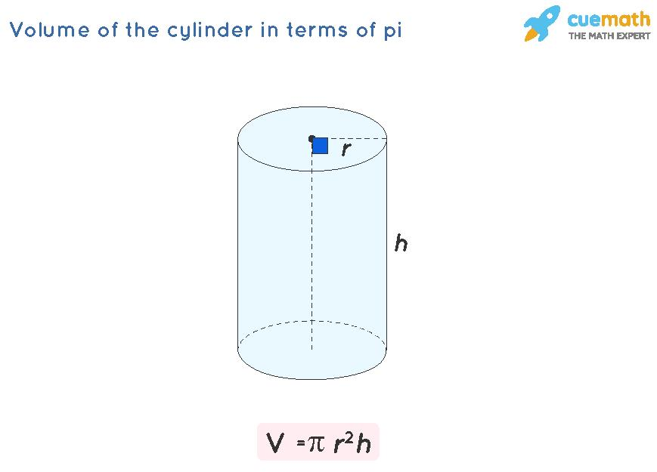

Characteristics
# Source: AI Source: Provided by: [Data Path: Persons Table -> ID Column: 1, Name_En Column: Motasem Essam] -> From: [ChatGPT] on [7/20/2026]
Volume:
- Is a three-dimensional measurement.
- Measures the space occupied or enclosed by a solid.
- Is measured in cubic units.
- Depends on three-dimensional dimensions such as length, width, height, or radius and height.
- Is always nonnegative.
$$\boxed{V≥0}$$
Its dimensional form is:
$$\boxed{\left[V\right]=L^{3}}$$

Volume and Cubic Units
# Source: AI Source: Provided by: [Data Path: Persons Table -> ID Column: 1, Name_En Column: Motasem Essam] -> From: [ChatGPT] on [7/20/2026]
Volume can be understood by filling a solid with equal-sized cubes.
For example, a rectangular prism measuring:
$$l=4, w=3, h=2$$
contains:
$$4×3×2=24$$
unit cubes.
Therefore:
$$\boxed{V=24\text{ cubic units}}$$
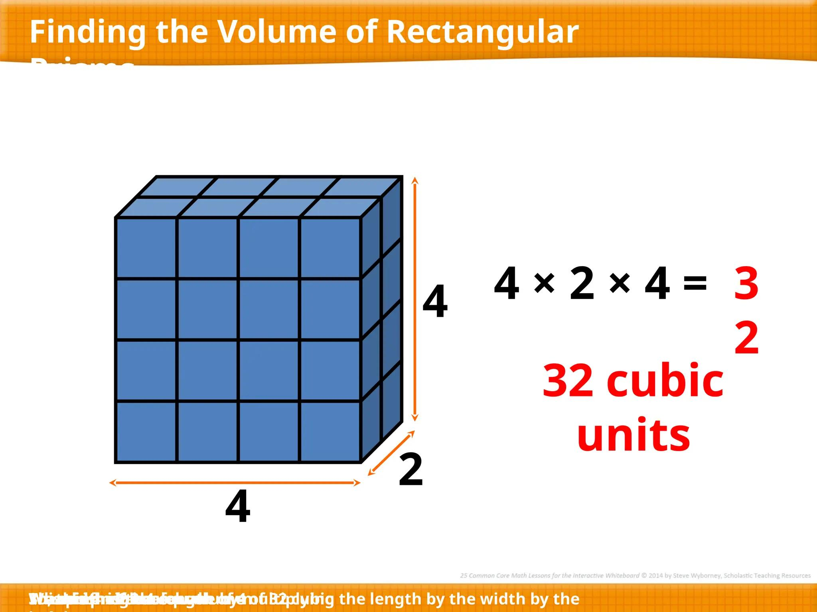
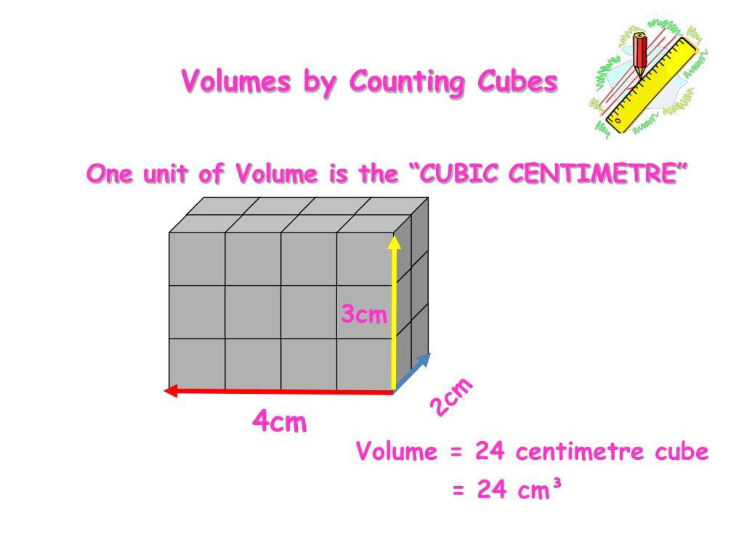
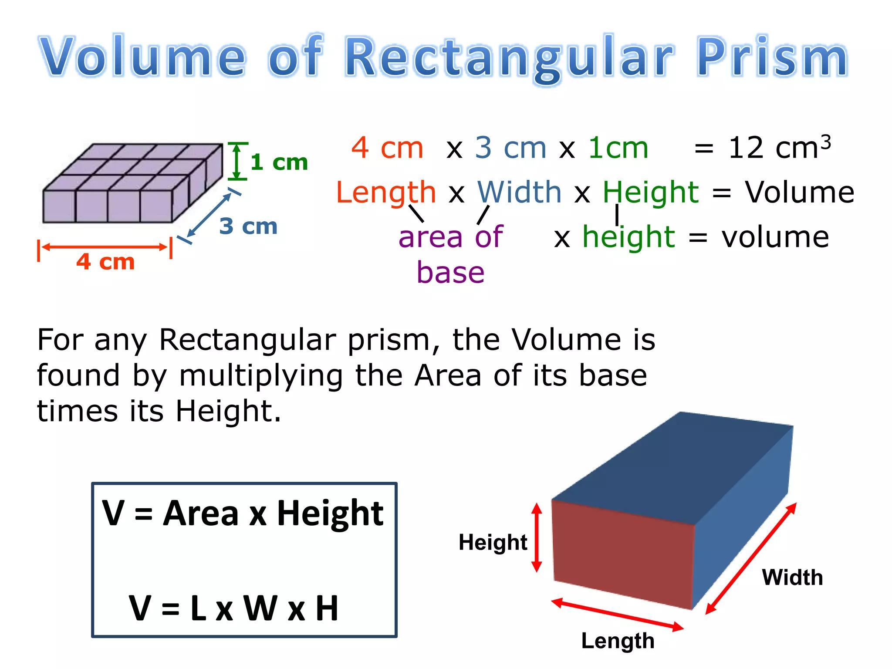
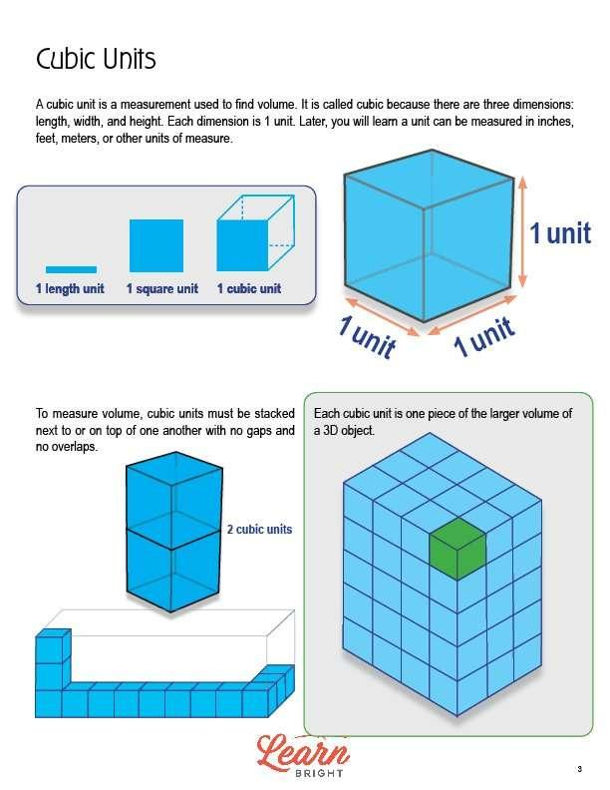
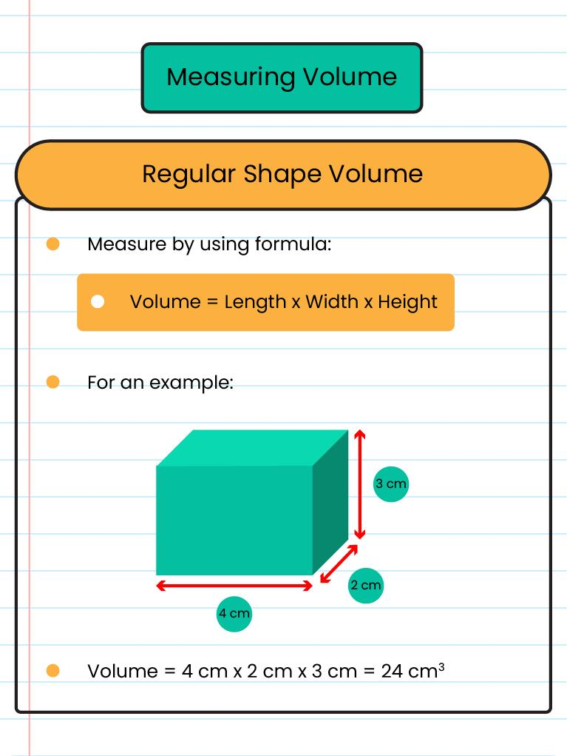

Volume of Common Geometric Solids

1. Cube
# Source: AI Source: Provided by: [Data Path: Persons Table -> ID Column: 1, Name_En Column: Motasem Essam] -> From: [ChatGPT] on [7/20/2026]
For a cube with side length $s$:
$$\boxed{V=s^{3}}$$
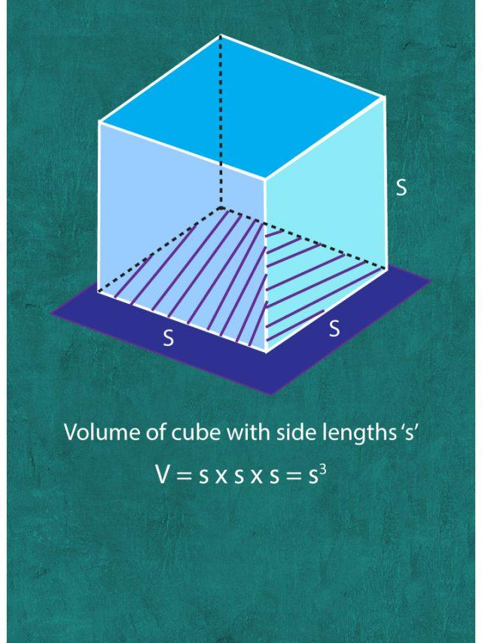
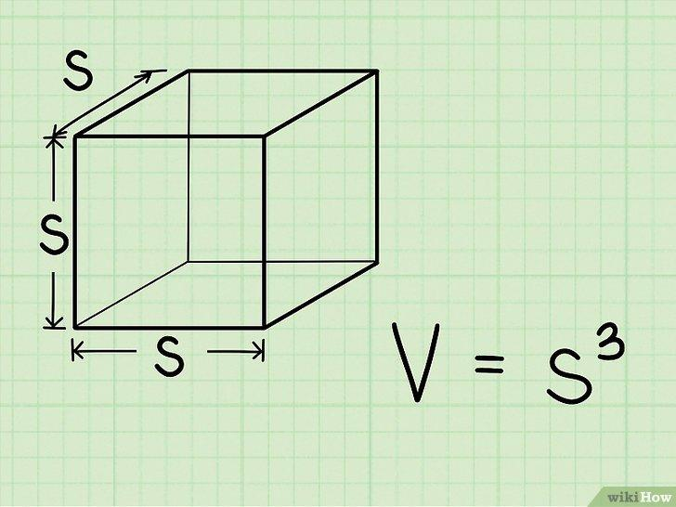
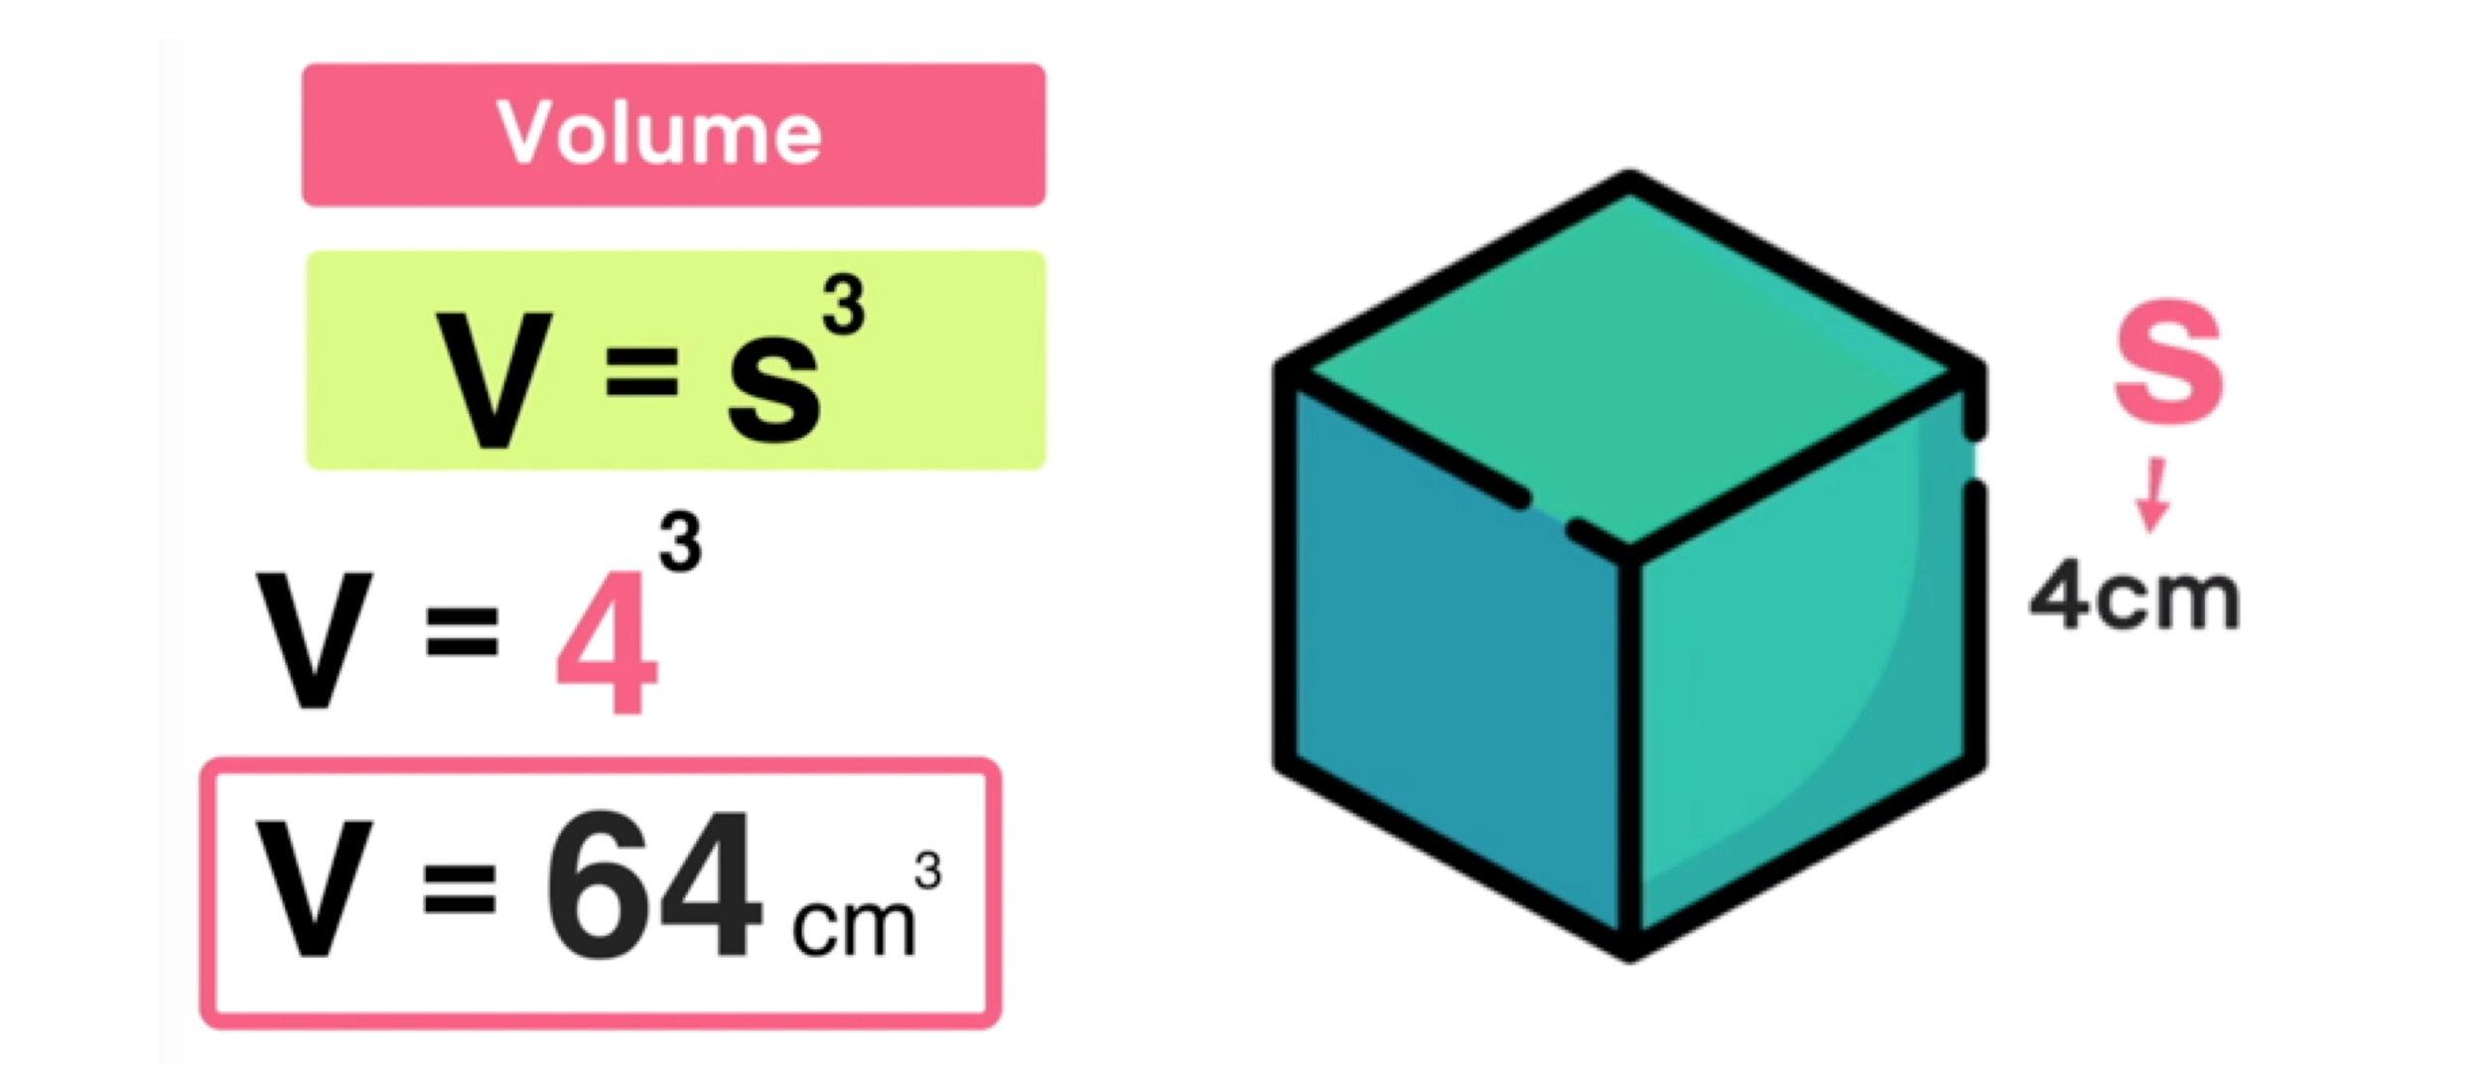
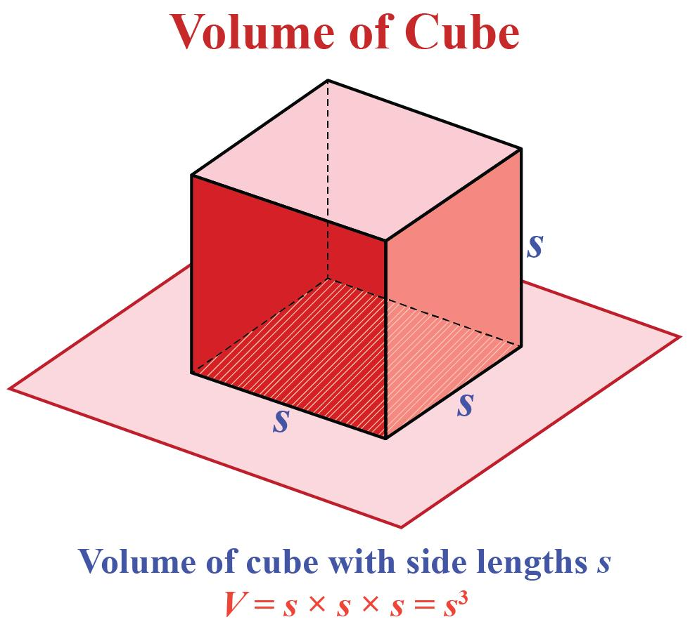
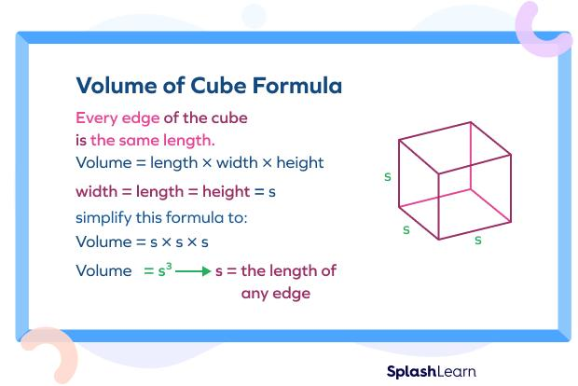

2. Rectangular Prism
# Source: AI Source: Provided by: [Data Path: Persons Table -> ID Column: 1, Name_En Column: Motasem Essam] -> From: [ChatGPT] on [7/20/2026]
For length $l$, width $w$, and height $h$:
$$\boxed{V=lwh}$$
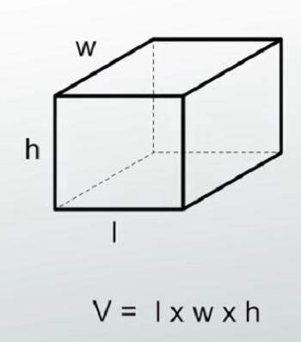
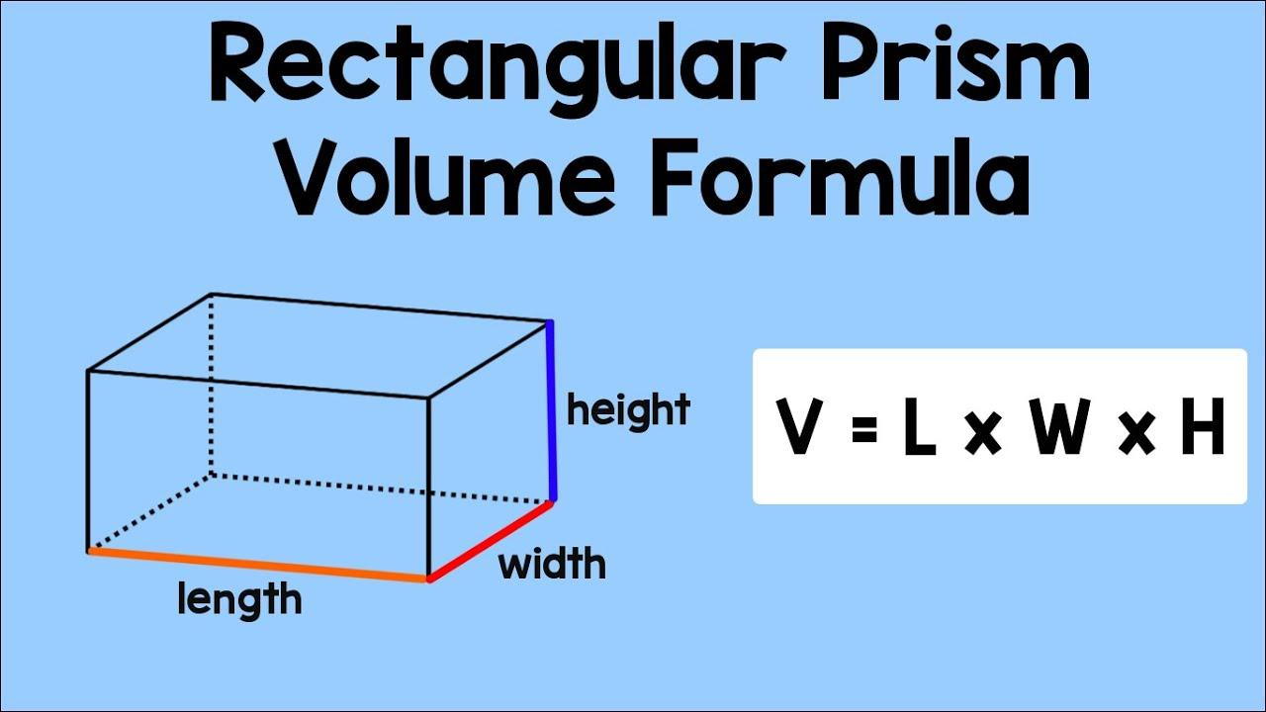
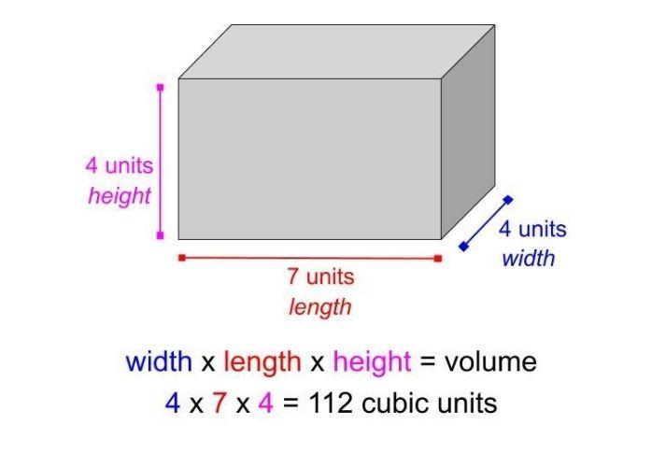
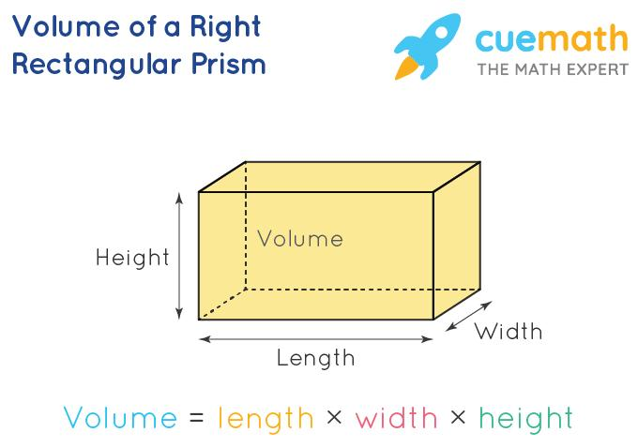
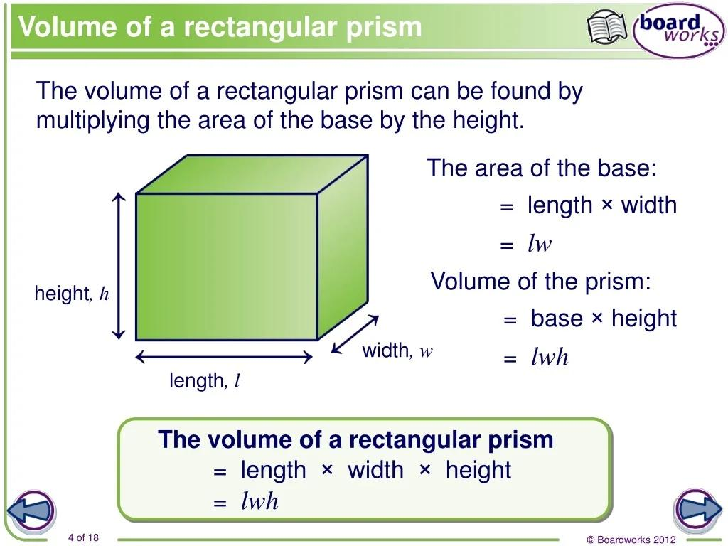

3. Cylinder
# Source: AI Source: Provided by: [Data Path: Persons Table -> ID Column: 1, Name_En Column: Motasem Essam] -> From: [ChatGPT] on [7/20/2026]
For radius $r$ and height $h$:
$$\boxed{V=πr^{2}h}$$
The formula can be understood as:
$$\boxed{V=\left(\text{Base Area}\right)\left(\text{Height}\right)}$$
because the circular base has area:
$$A=πr^{2}$$

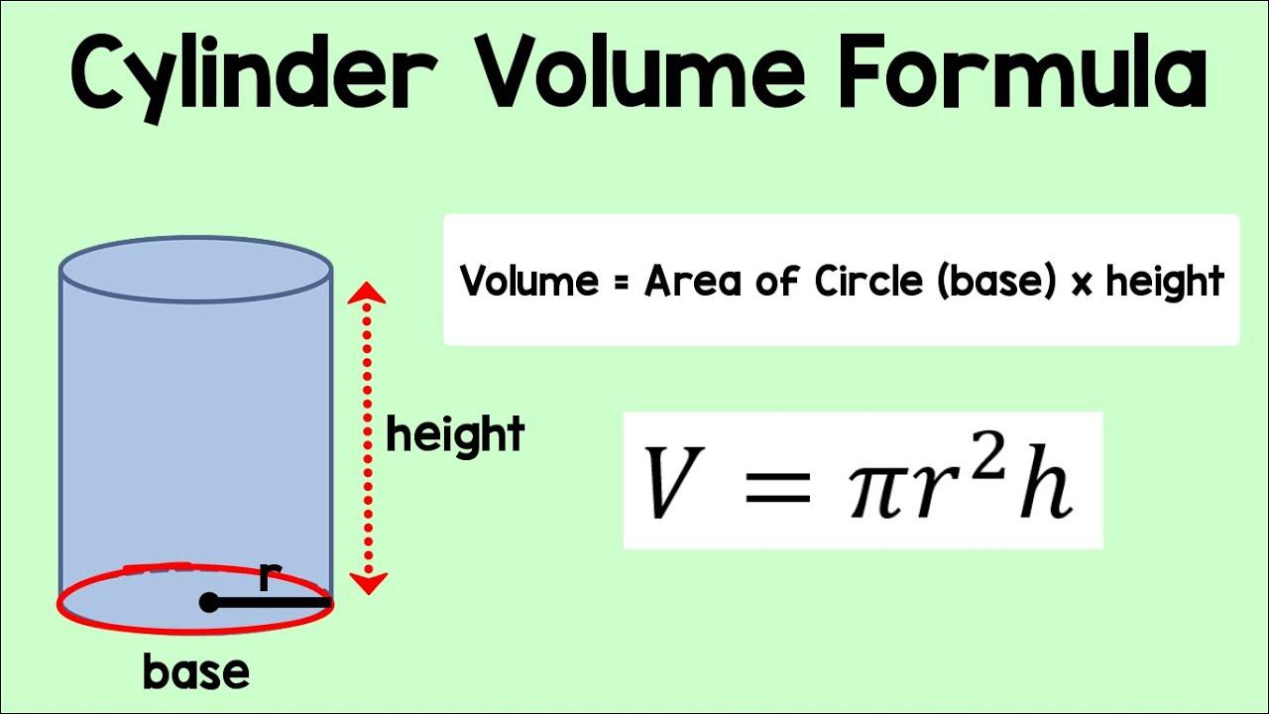
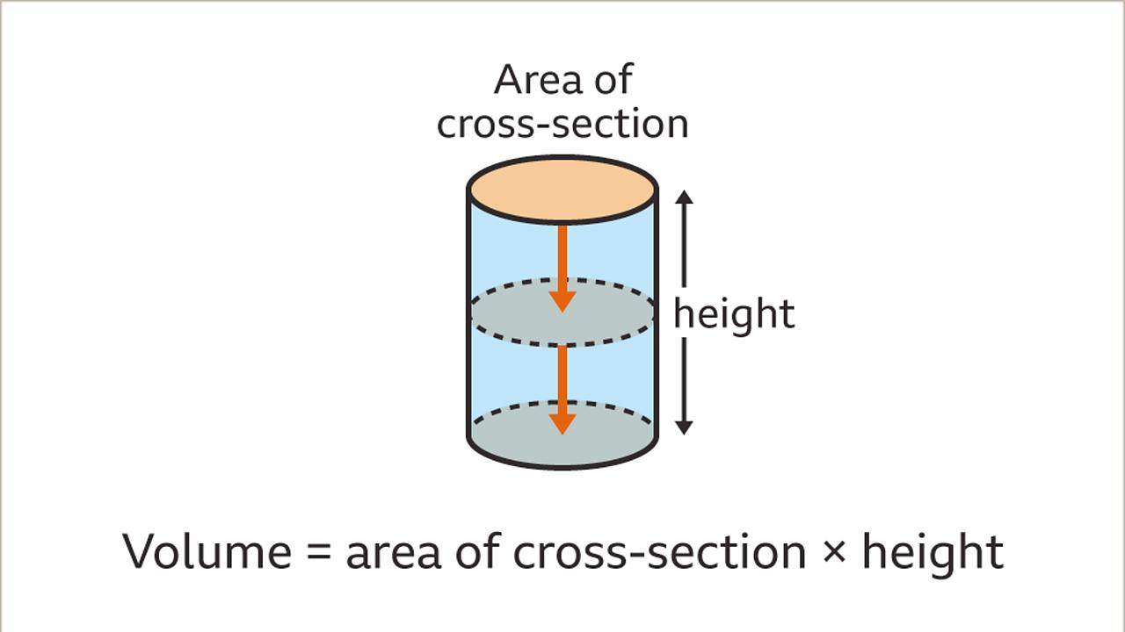
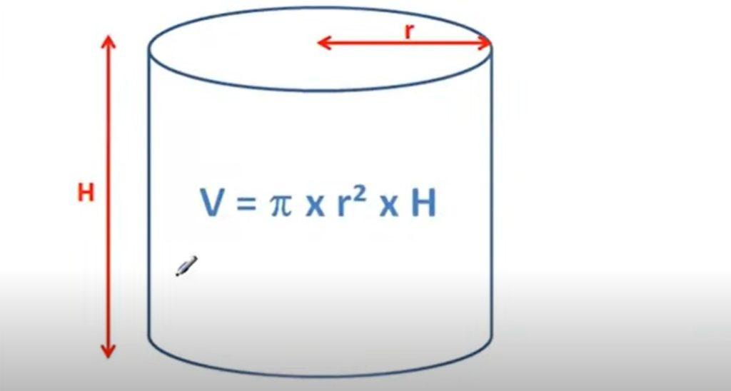
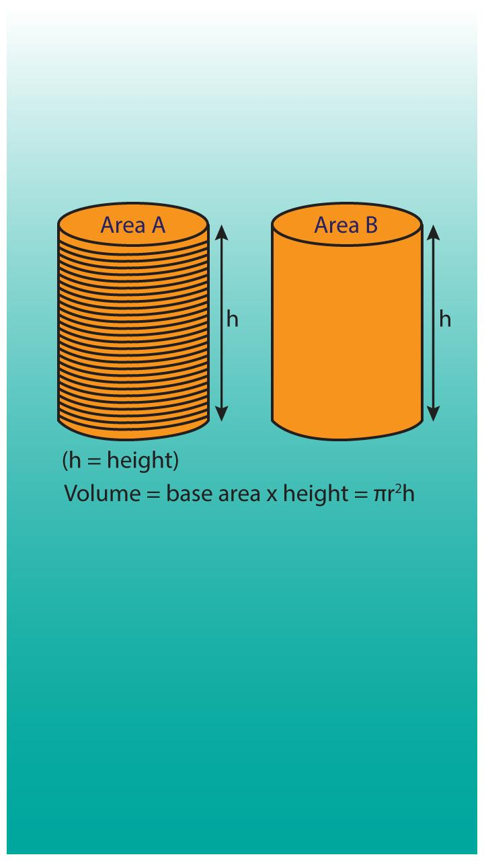

4. Prism
# Source: AI Source: Provided by: [Data Path: Persons Table -> ID Column: 1, Name_En Column: Motasem Essam] -> From: [ChatGPT] on [7/20/2026]
For any prism:
$$\boxed{V=Bh}$$
where:
- $B$ = area of the base
- $h$ = perpendicular height
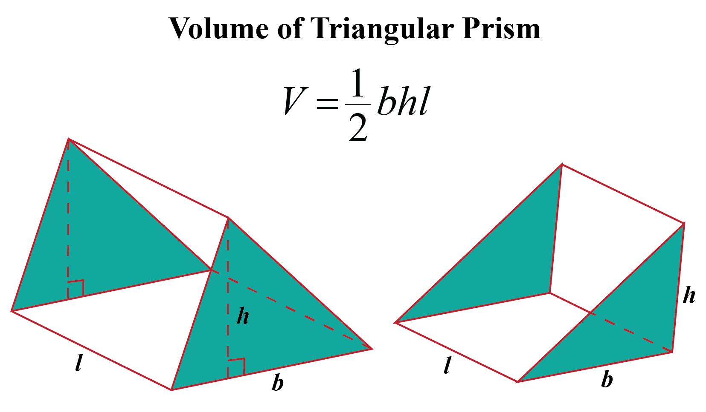
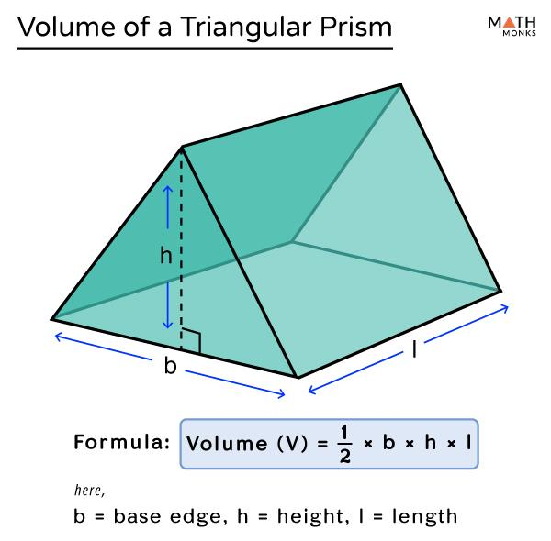
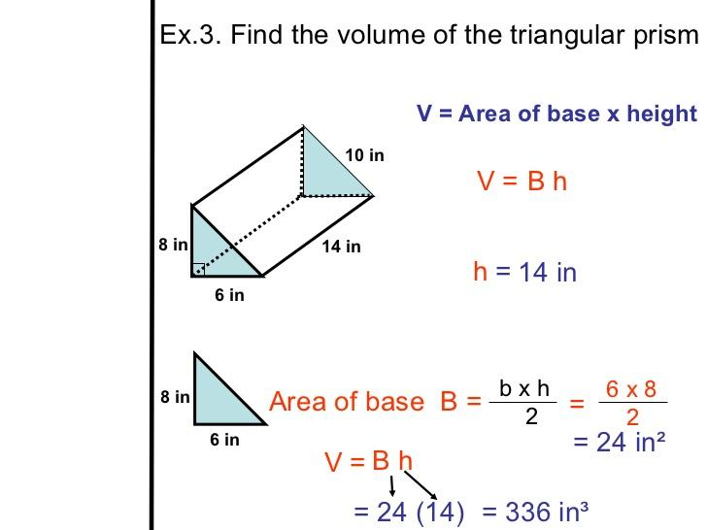
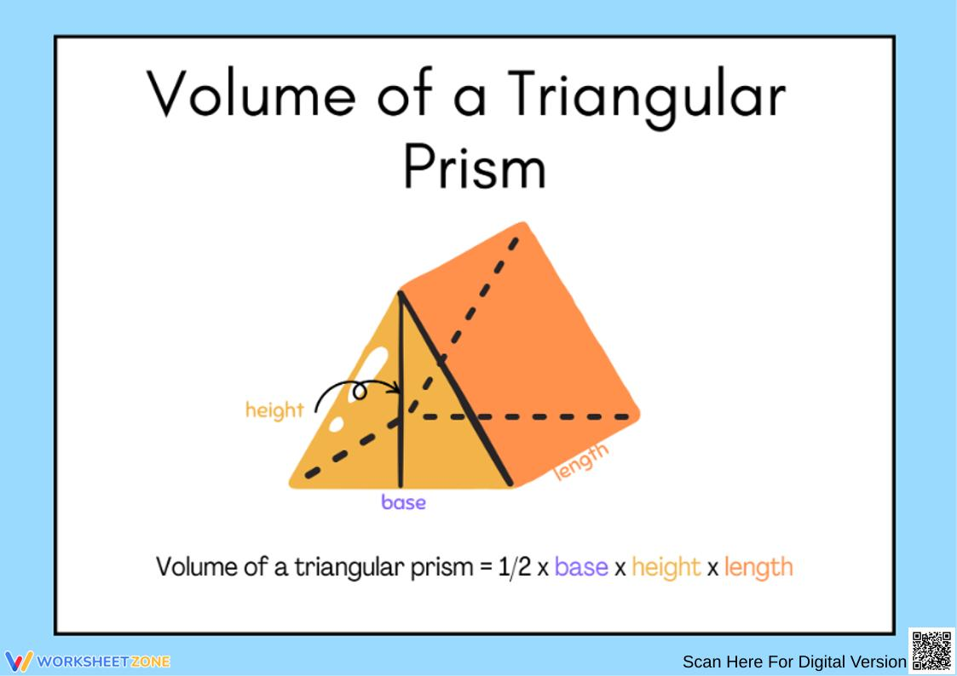
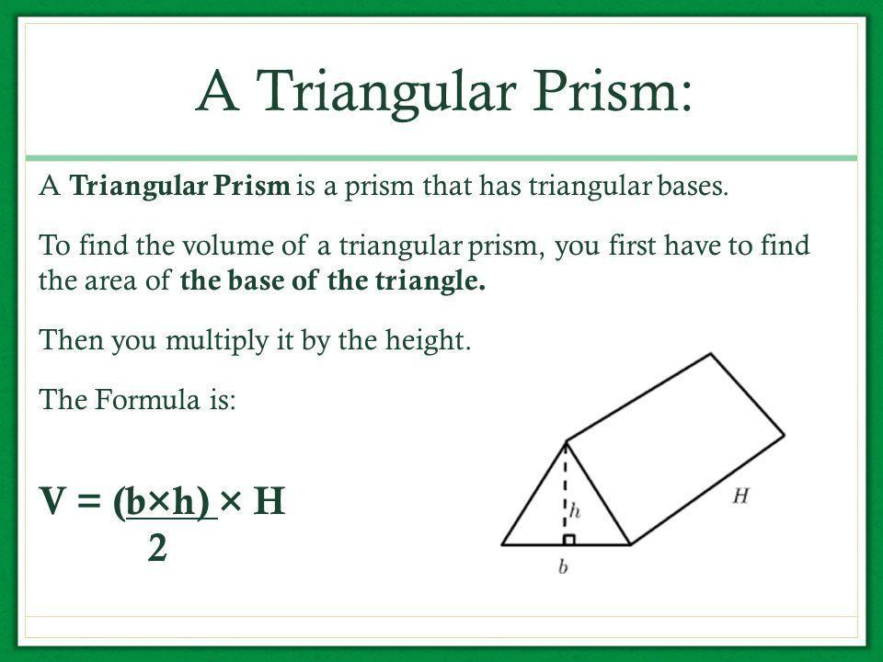

5. Pyramid
# Source: AI Source: Provided by: [Data Path: Persons Table -> ID Column: 1, Name_En Column: Motasem Essam] -> From: [ChatGPT] on [7/20/2026]
For a pyramid:
$$\boxed{V=\frac{1}{3}Bh}$$
where:
- $B$ = area of the base
- $h$ = perpendicular height
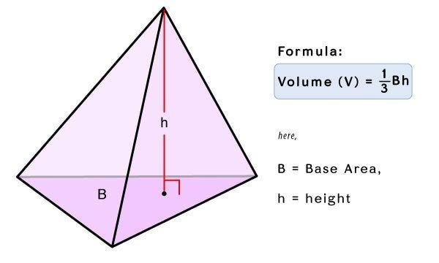
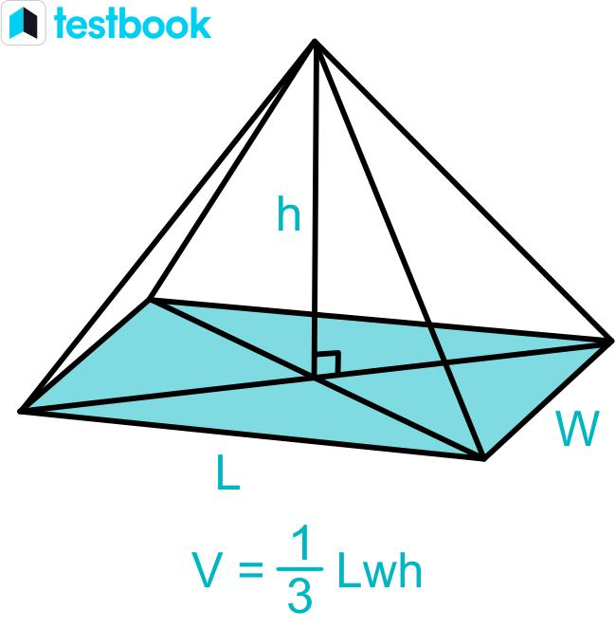
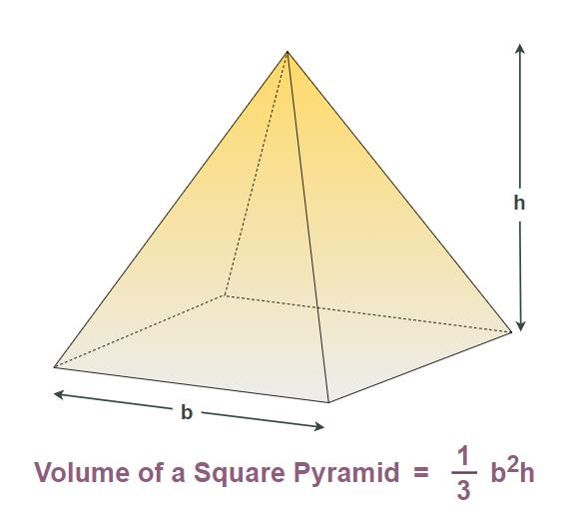
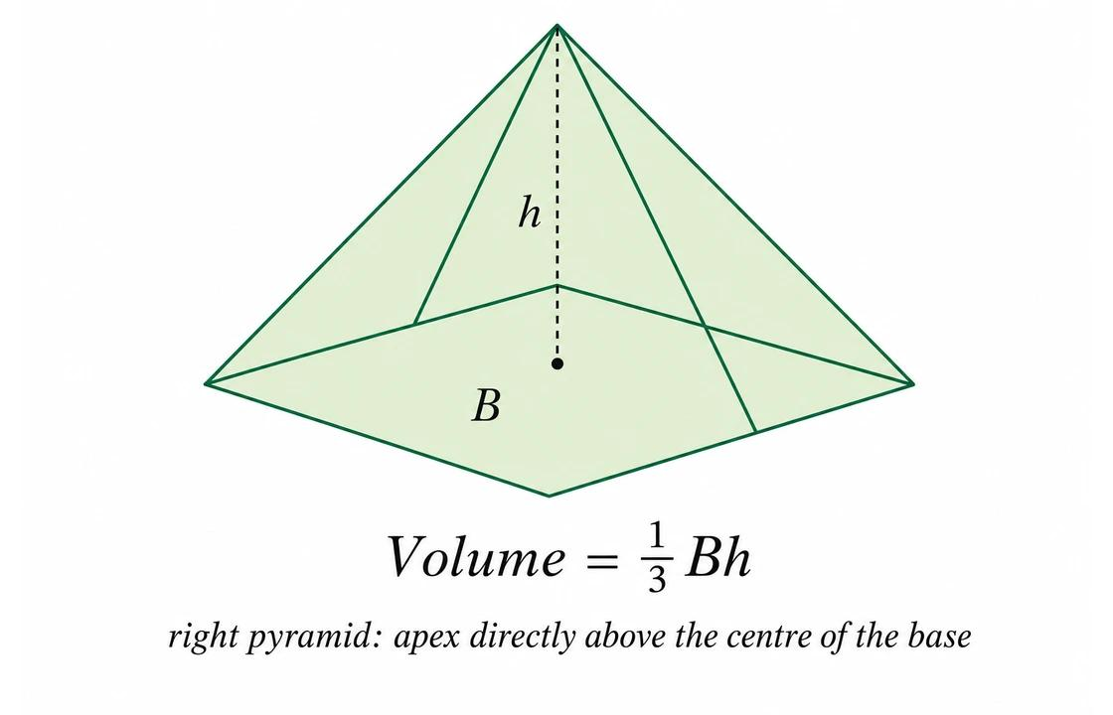
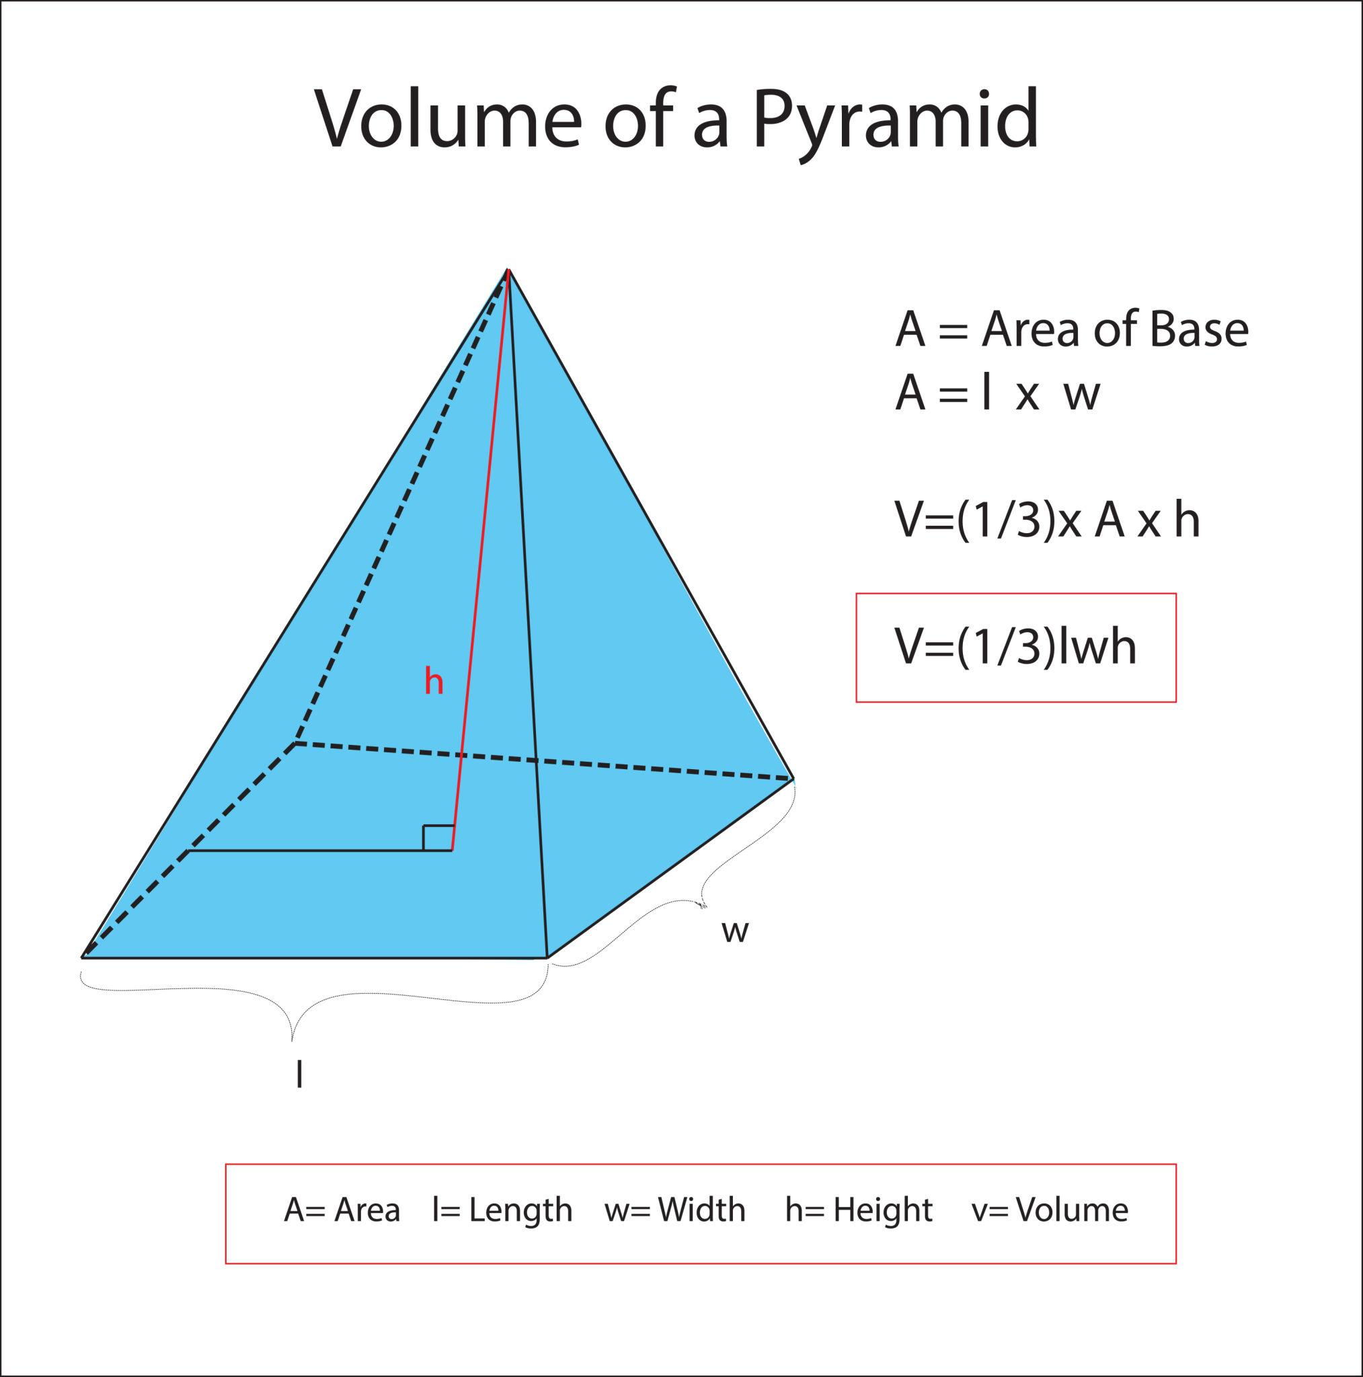

6. Cone
# Source: AI Source: Provided by: [Data Path: Persons Table -> ID Column: 1, Name_En Column: Motasem Essam] -> From: [ChatGPT] on [7/20/2026]
For a cone:
$$\boxed{V=\frac{1}{3}πr^{2}h}$$
or:
$$\boxed{V=\frac{1}{3}Bh}$$
where $B=πr^{2}$.
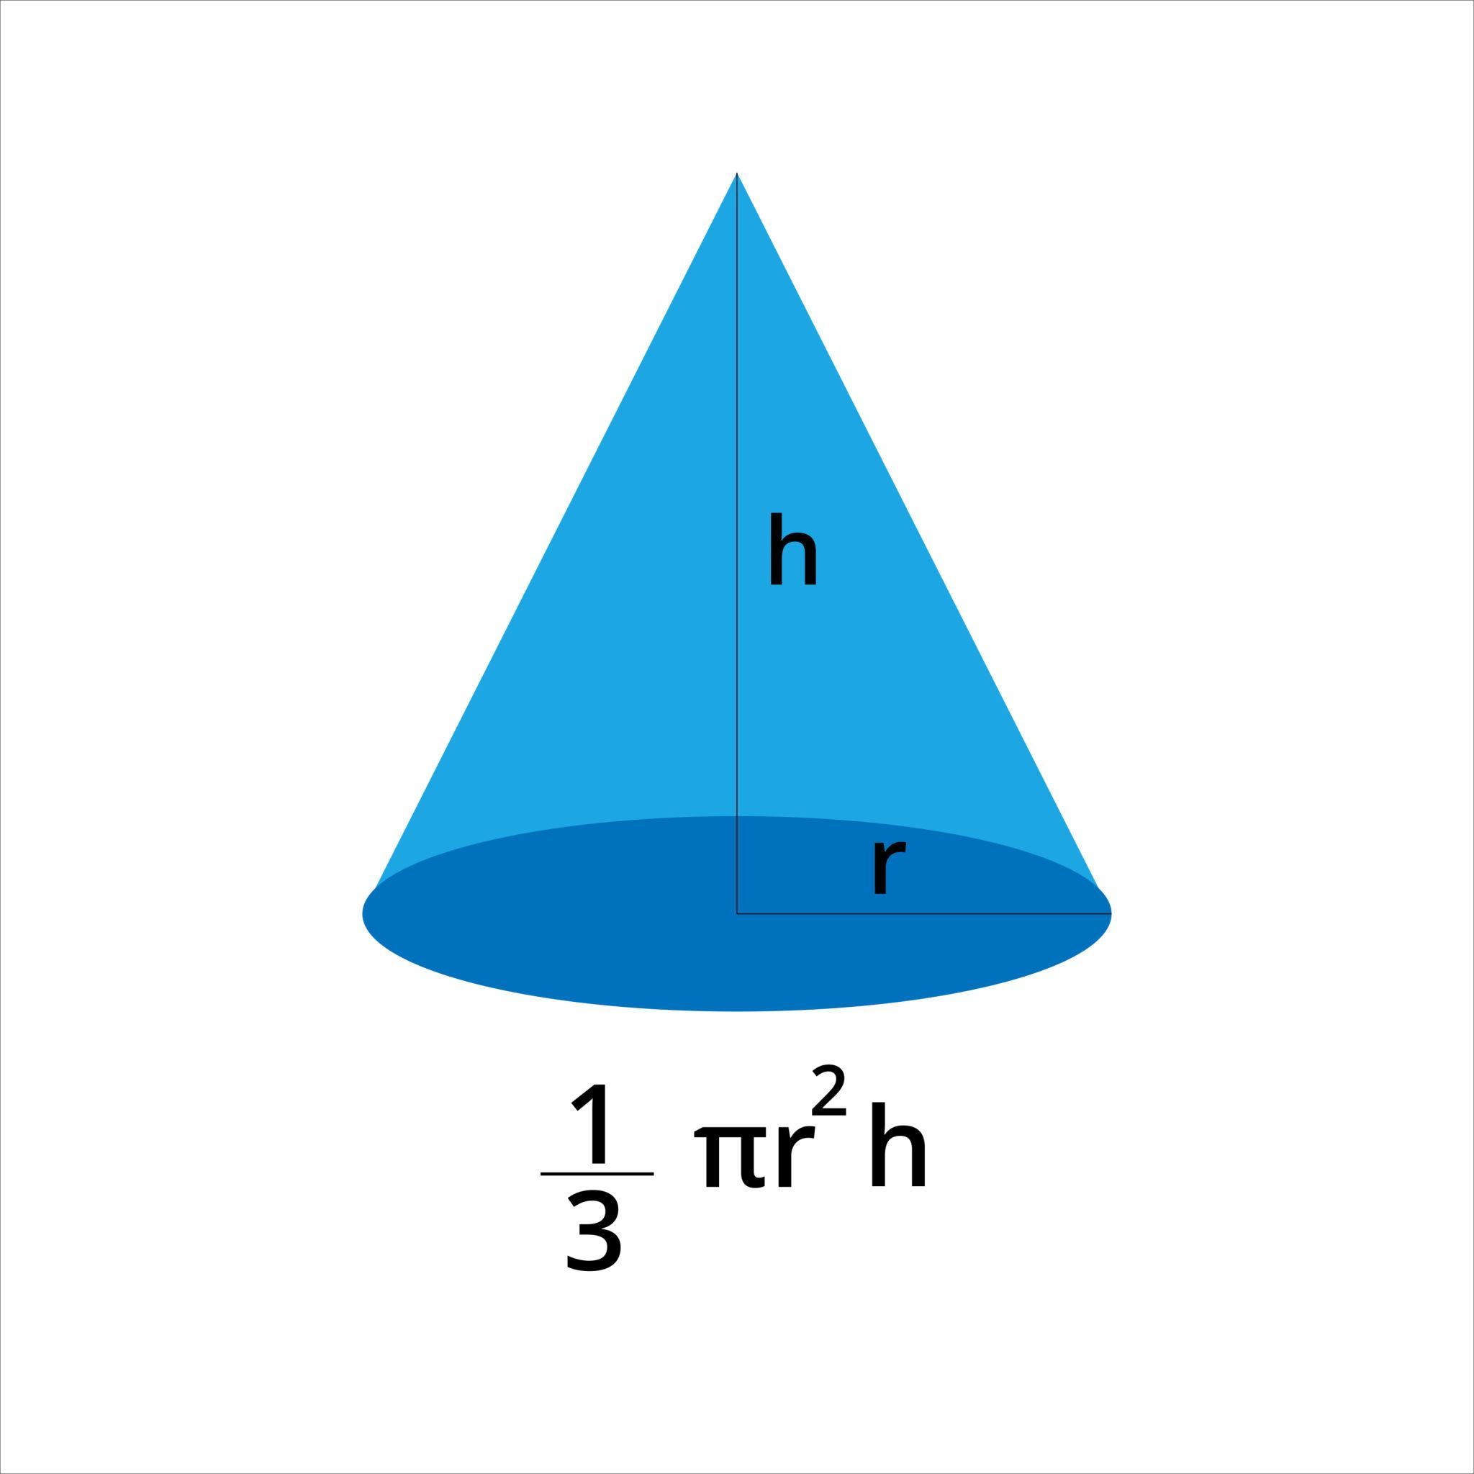
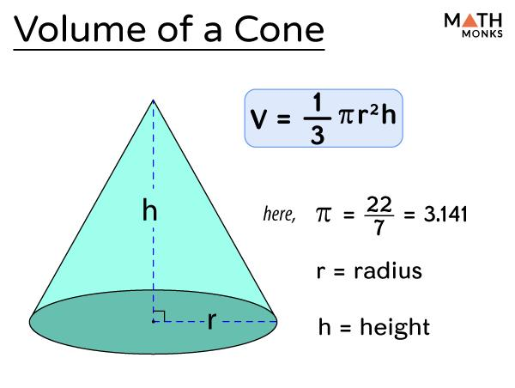
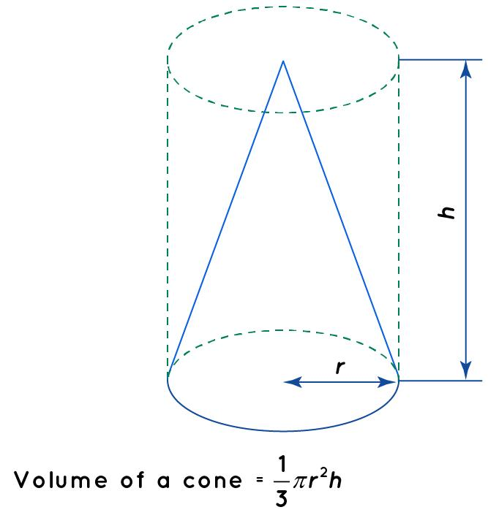
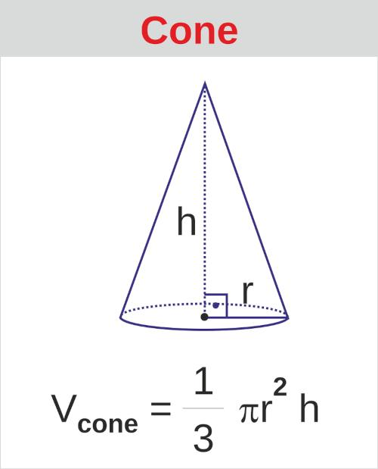

7. Sphere
# Source: AI Source: Provided by: [Data Path: Persons Table -> ID Column: 1, Name_En Column: Motasem Essam] -> From: [ChatGPT] on [7/20/2026]
For a sphere with radius $r$:
$$\boxed{V=\frac{4}{3}πr^{3}}$$
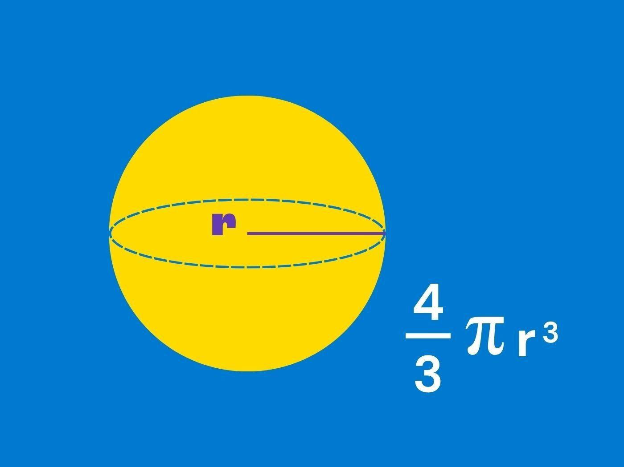
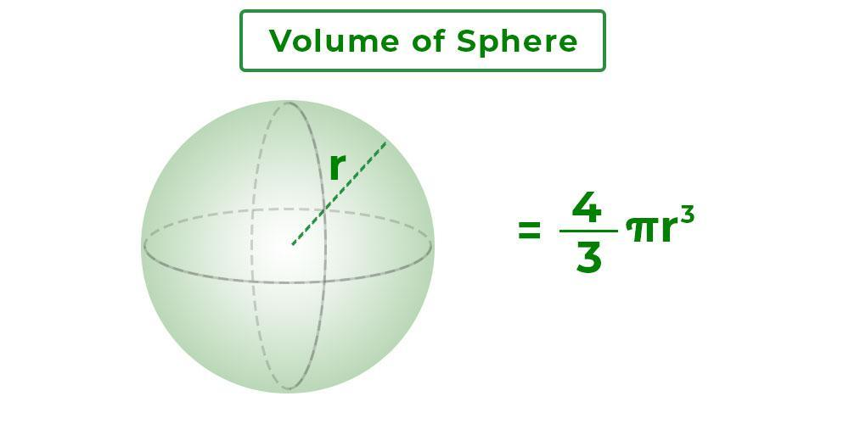
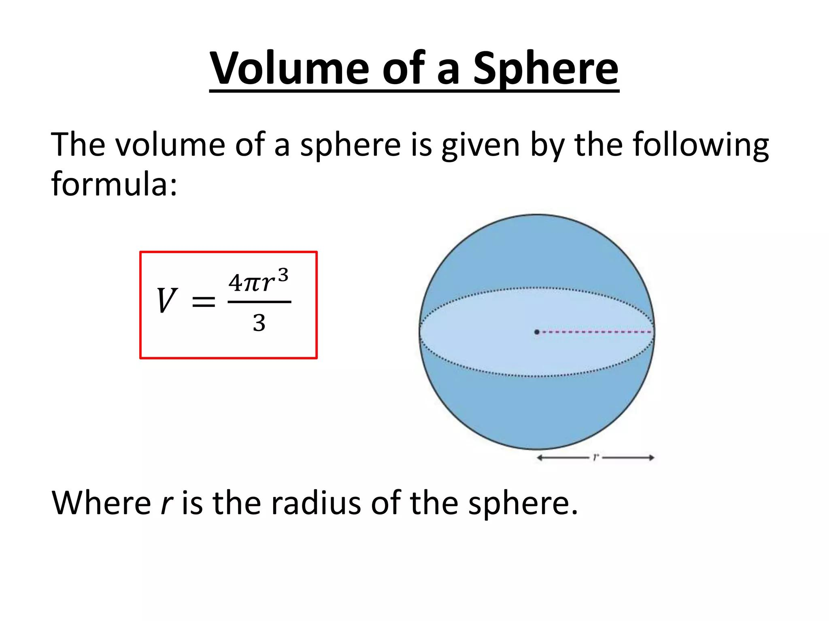
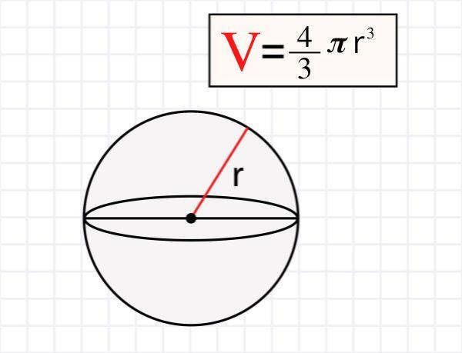
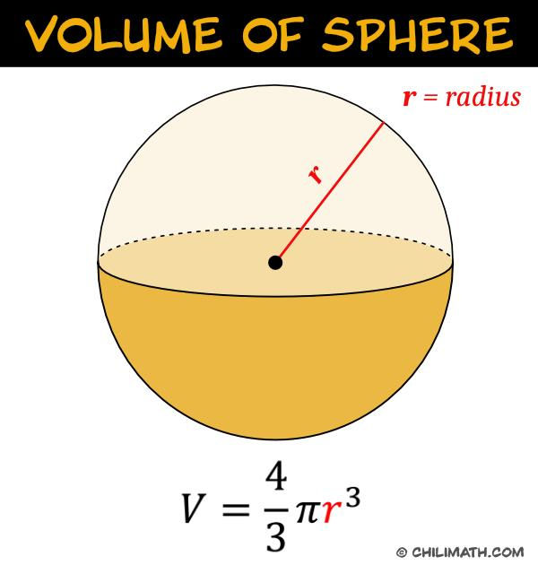

Volume vs. Surface Area
# Source: AI Source: Provided by: [Data Path: Persons Table -> ID Column: 1, Name_En Column: Motasem Essam] -> From: [ChatGPT] on [7/20/2026]
These concepts measure different properties.
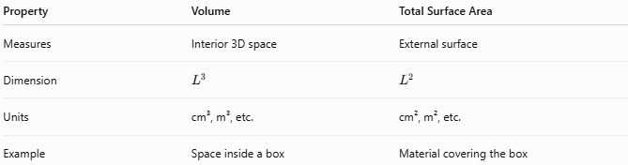
Property | Volume | Total Surface Area
Measures | Interior 3D space | External surface
Dimension | $$L^{3}$$ | $$L^{2}$$
Units | cm³, m³, etc. | cm², m², etc.
Example | Space inside a box | Material covering the box
For a rectangular prism:
$$\boxed{V=lwh}$$
while:
$$\boxed{SA=2\left(lw+lh+wh\right)}$$
Therefore:
$$\boxed{\text{Volume}≠\text{Surface Area}}$$
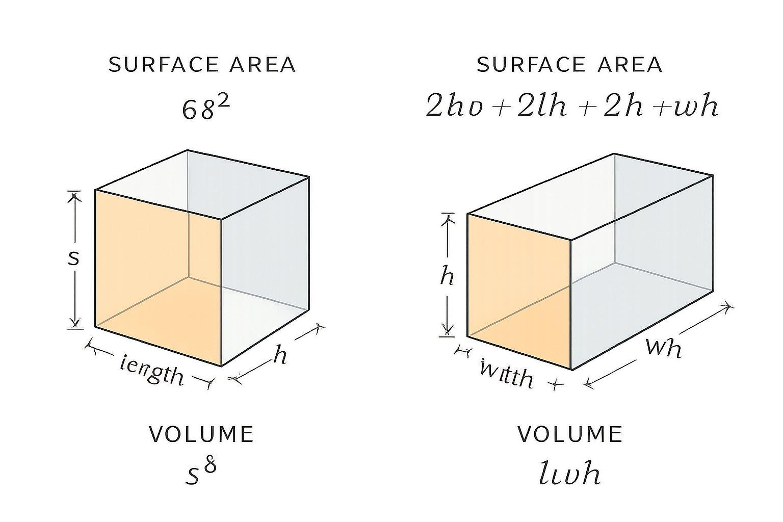
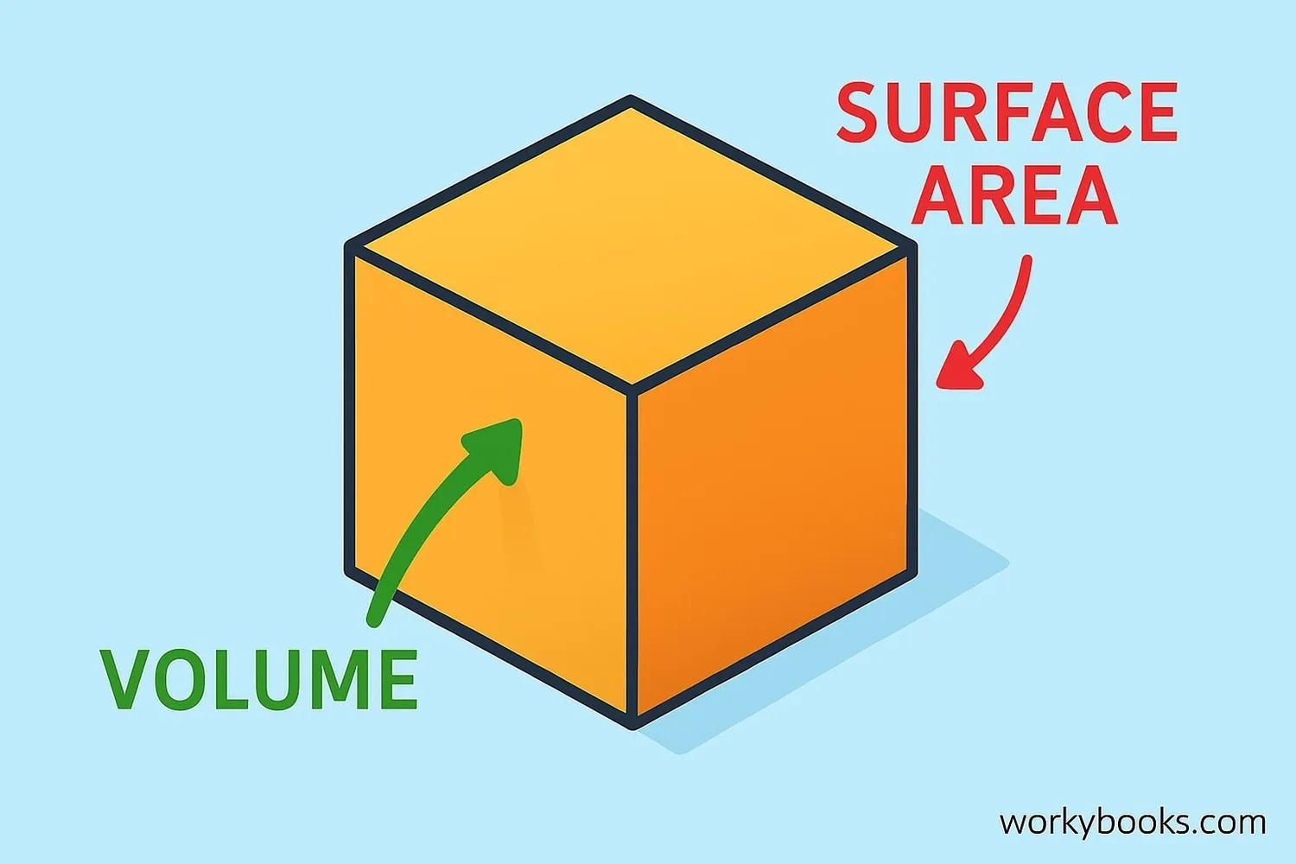
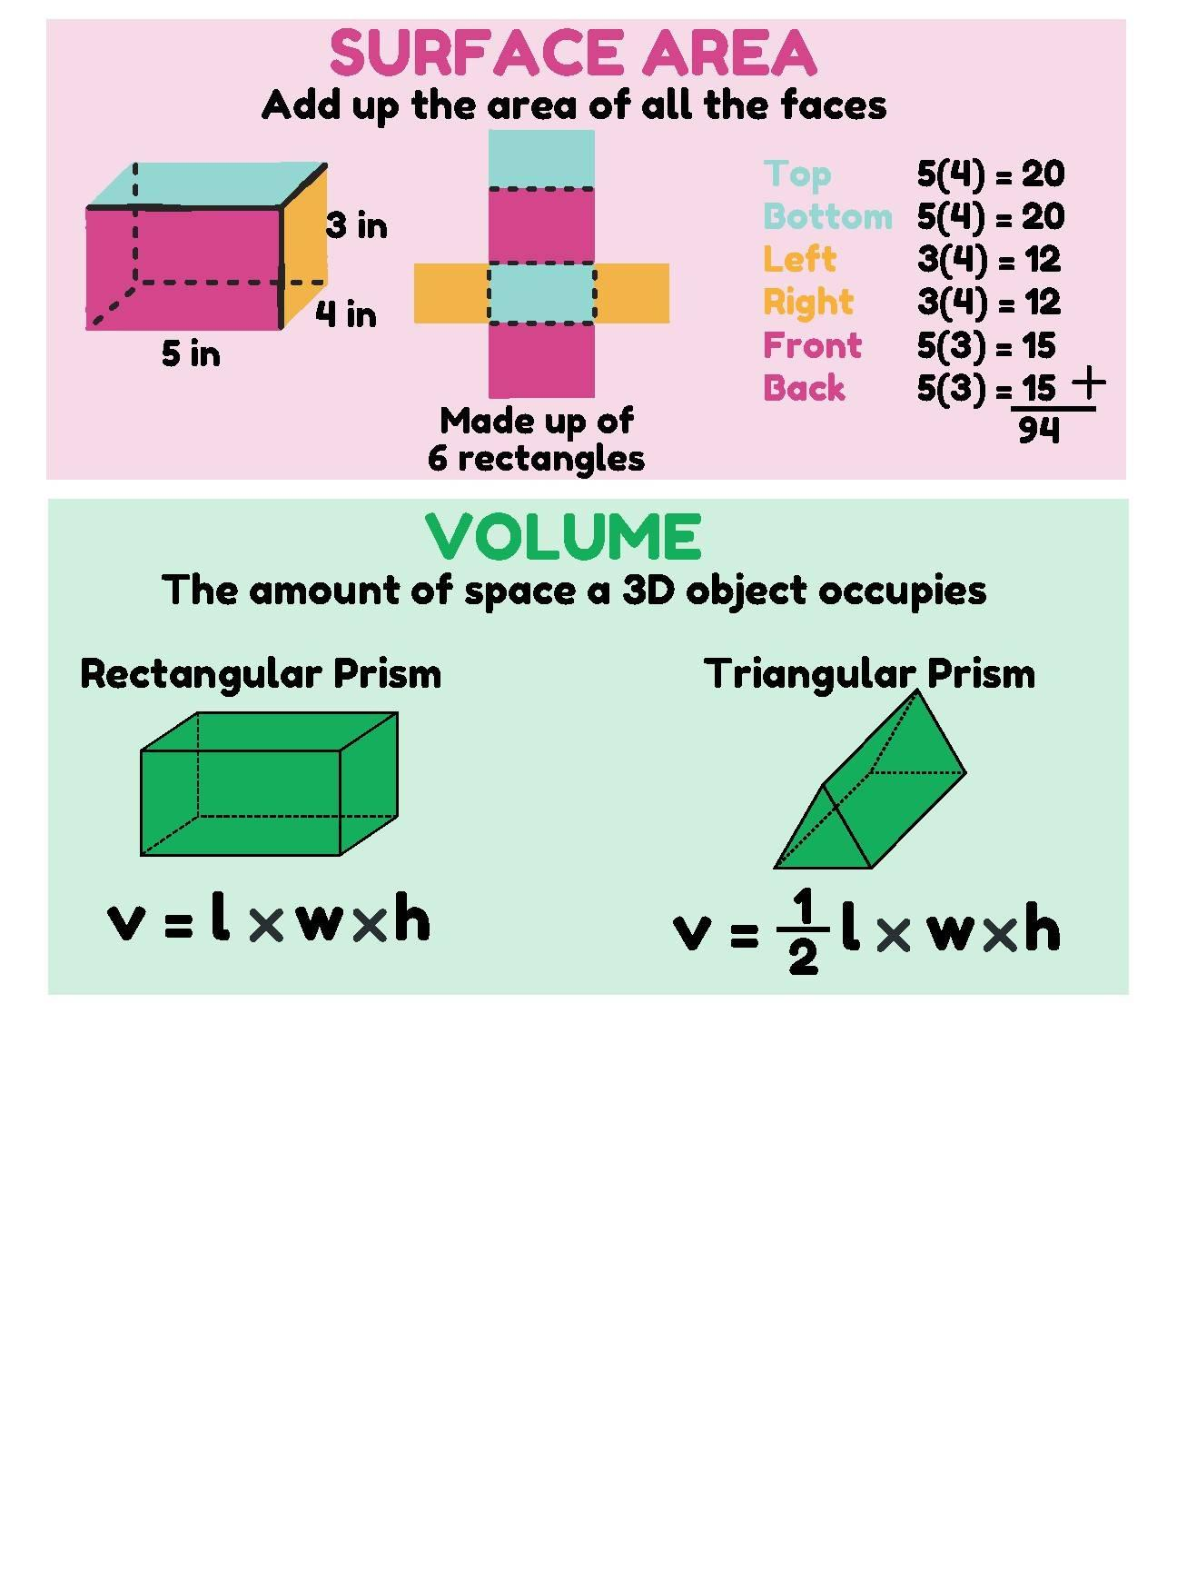


Volume vs. Area
# Source: AI Source: Provided by: [Data Path: Persons Table -> ID Column: 1, Name_En Column: Motasem Essam] -> From: [ChatGPT] on [7/20/2026]
Area measures a two-dimensional region:
$$\boxed{\left[A\right]=L^{2}}$$
while volume measures three-dimensional space:
$$\boxed{\left[V\right]=L^{3}}$$
For example:
$$\text{Rectangle}→\text{Area} \\ \text{Rectangular Prism}→\text{Volume}$$

Volume and Base
# Source: AI Source: Provided by: [Data Path: Persons Table -> ID Column: 1, Name_En Column: Motasem Essam] -> From: [ChatGPT] on [7/20/2026]
For many solids, volume can be expressed using the base area and perpendicular height.
For a prism:
$$\boxed{V=Bh}$$
For a cylinder:
$$\boxed{V=πr^{2}h}$$
For a pyramid:
$$\boxed{V=\frac{1}{3}Bh}$$
For a cone:
$$\boxed{V=\frac{1}{3}πr^{2}h}$$
This makes base area an important component of volume calculations.

Volume and Scaling
# Source: AI Source: Provided by: [Data Path: Persons Table -> ID Column: 1, Name_En Column: Motasem Essam] -> From: [ChatGPT] on [7/20/2026]
If every linear dimension of a solid is multiplied by a scale factor $k$, its volume is multiplied by:
$$\boxed{k^{3}}$$
For example, if a solid is enlarged by a factor of $2$:
$$V_{\text{new}}=2^{3}V_{\text{old}} \\ \boxed{V_{\text{new}}=8V_{\text{old}}}$$
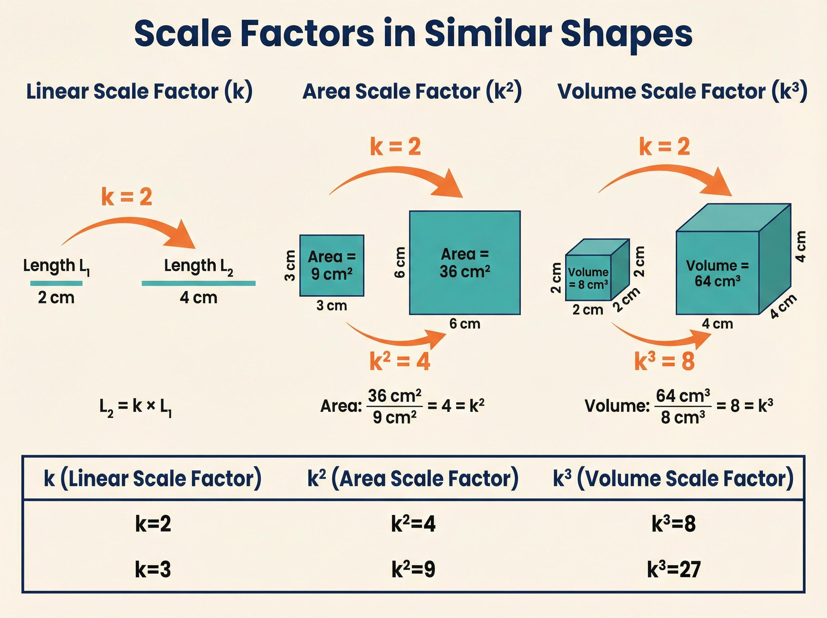
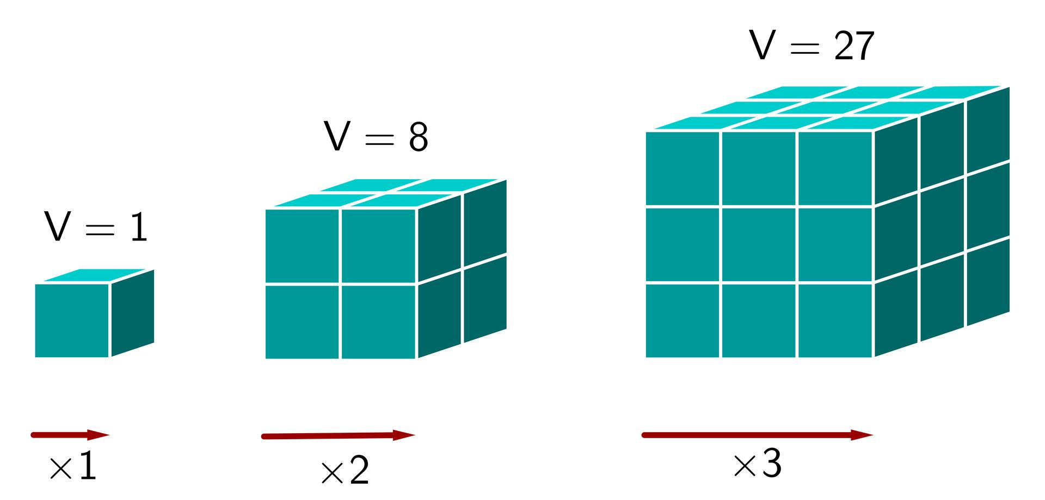
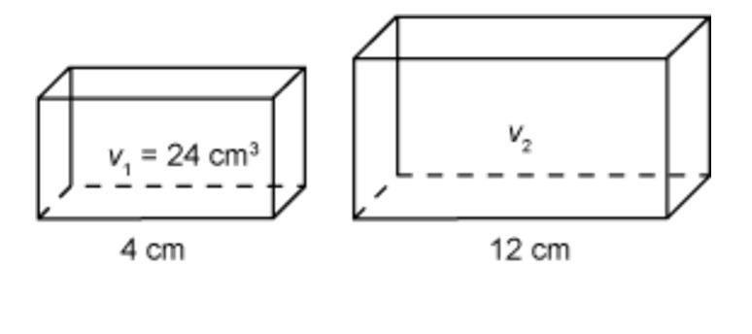
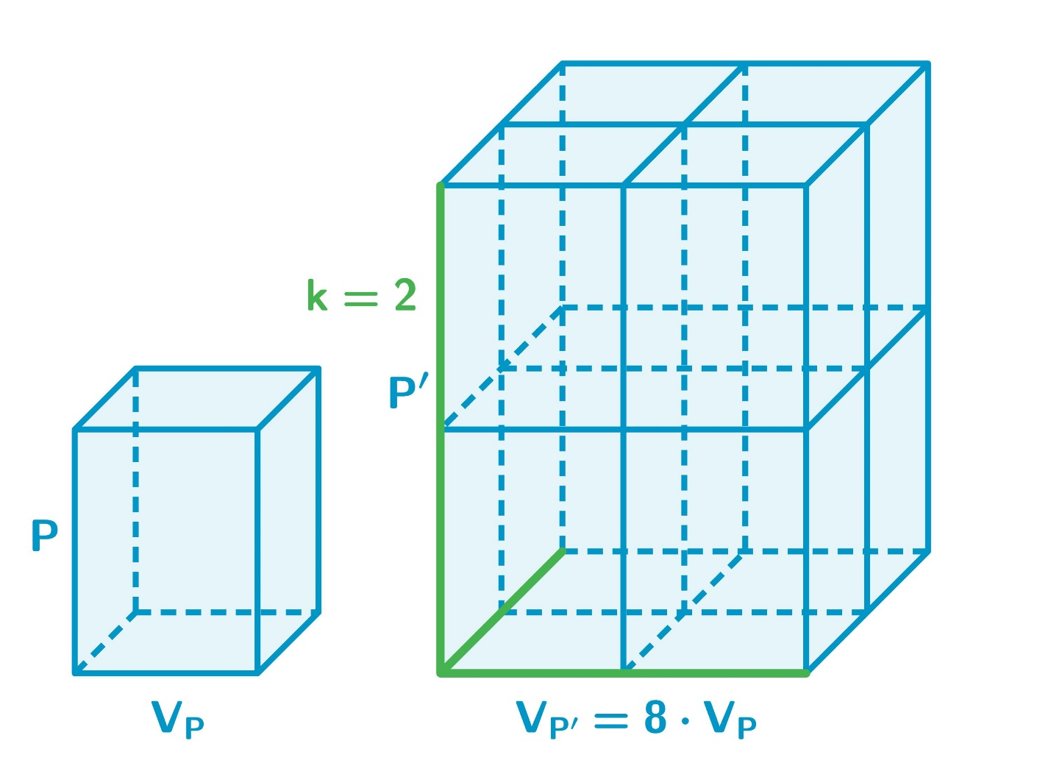
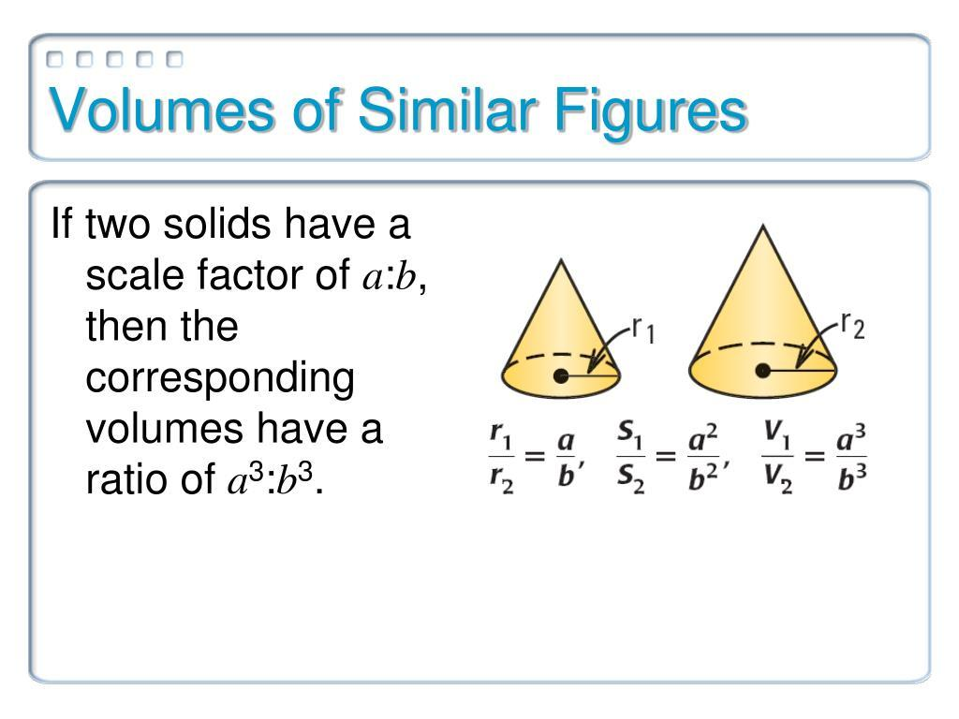
This differs from:
$$\text{Length}→k \\ \text{Area}→k^{2} \\ \text{Volume}→k^{3}$$

Volume of Irregular Solids
# Source: AI Source: Provided by: [Data Path: Persons Table -> ID Column: 1, Name_En Column: Motasem Essam] -> From: [ChatGPT] on [7/20/2026]
For irregular objects, volume can be determined using different methods.
Decomposition
Divide the object into simpler solids:
$$\boxed{V=V_{1}+V_{2}+V_{3}+⋯}$$
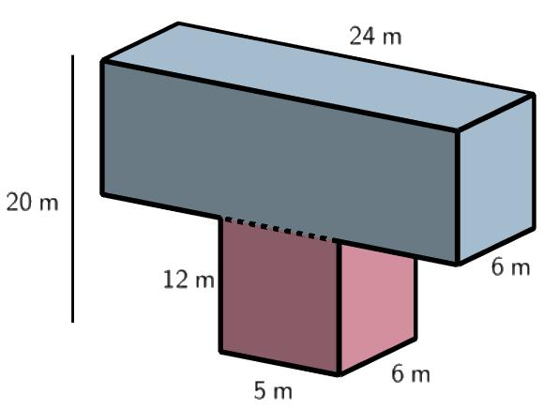
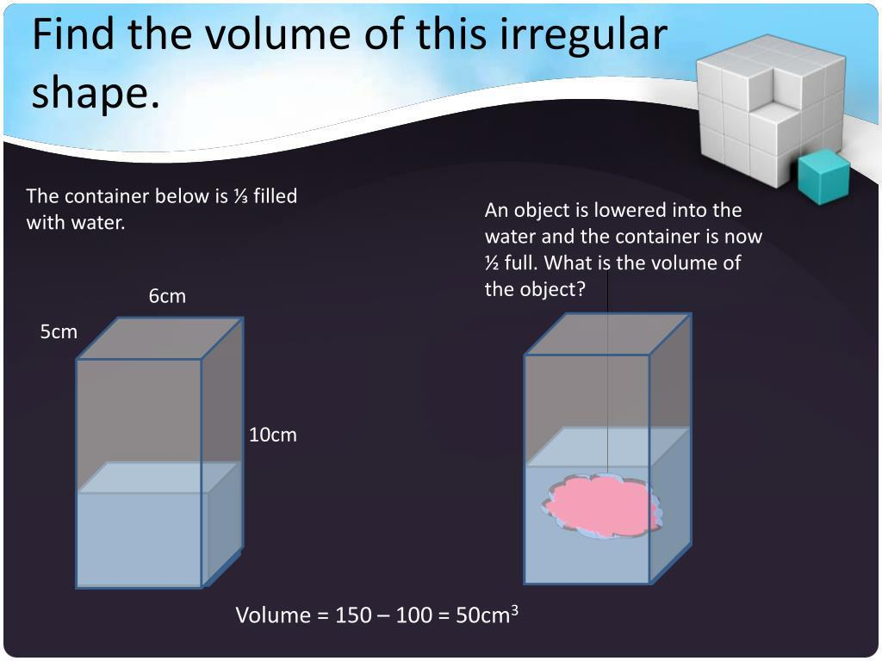
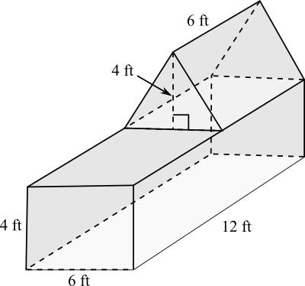
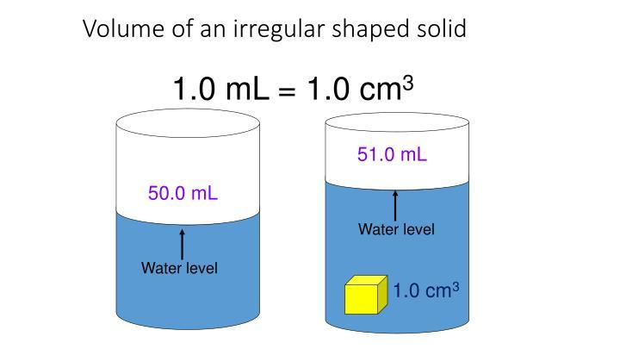
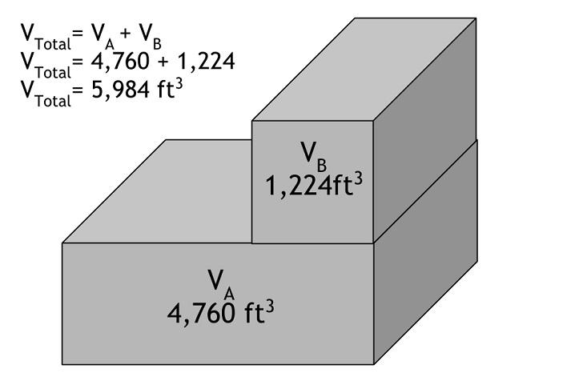
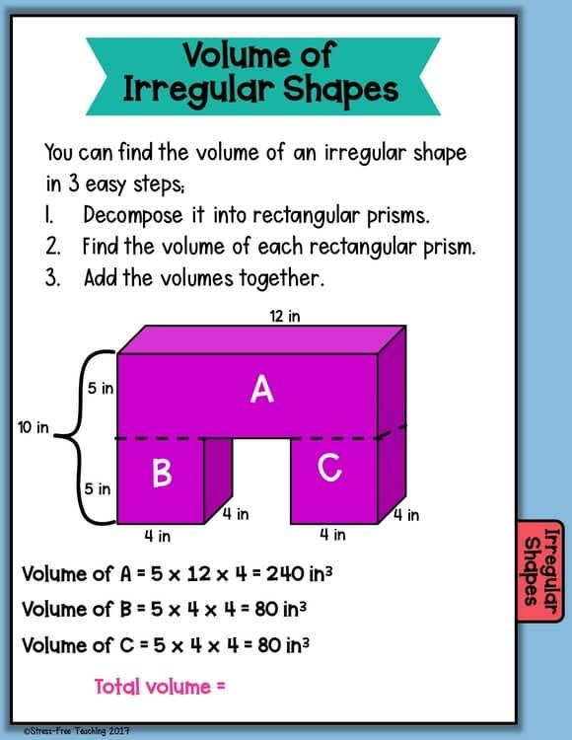
Subtraction
Start with a larger solid and remove an internal portion:
$$\boxed{V=V_{\text{large}}-V_{\text{removed}}}$$
Water Displacement
For an irregular physical object, its volume can be determined from the change in water level:
$$\boxed{V_{\text{object}}=V_{\text{final}}-V_{\text{initial}}}$$
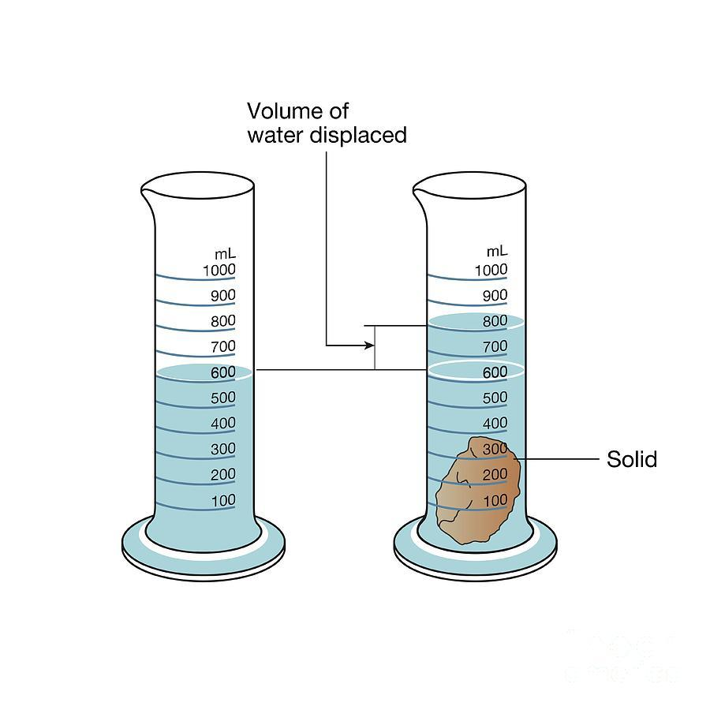
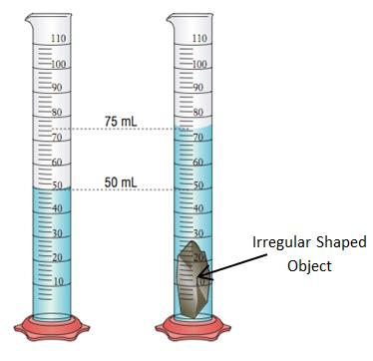
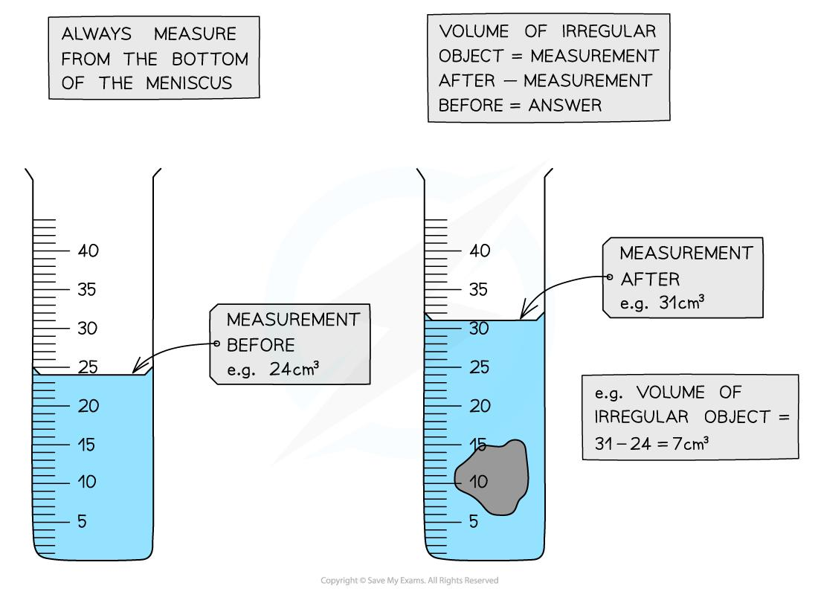
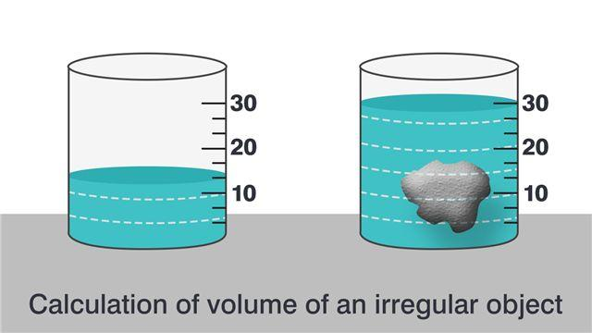
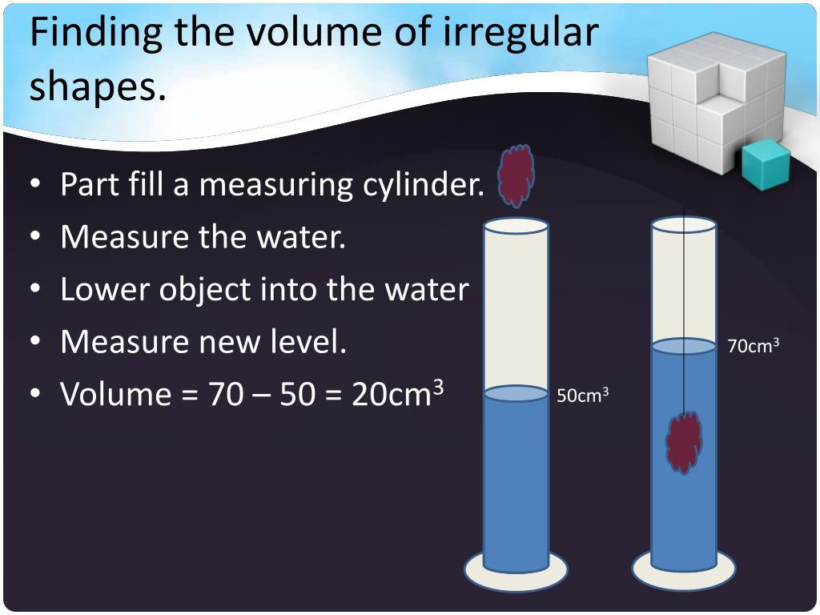

Volume Units
# Source: AI Source: Provided by: [Data Path: Persons Table -> ID Column: 1, Name_En Column: Motasem Essam] -> From: [ChatGPT] on [7/20/2026]
Because volume is three-dimensional, its units are cubic.
Examples:
$${\text{cm}}^{3} \\ {\text{m}}^{3} \\ {\text{km}}^{3}$$
Other common volume units include:
- liters (L)
- milliliters (mL)
For example:
$$\boxed{1\text{ mL}=1{\text{ cm}}^{3}}$$
and:
$$\boxed{1\text{ L}=1000{\text{ cm}}^{3}}$$

Applications
# Source: AI Source: Provided by: [Data Path: Persons Table -> ID Column: 1, Name_En Column: Motasem Essam] -> From: [ChatGPT] on [7/20/2026]
Volume is important in:
- Geometry
- Measurement Theory
- Engineering
- Architecture
- Construction
- Manufacturing
- Mechanical Design
- Technical Drawing
- CAD (Computer-Aided Design)
- 3D Modeling
- Packaging Design
- Fluid Mechanics
- Chemistry
- Physics
- Materials Science

Advantages
# Source: AI Source: Provided by: [Data Path: Persons Table -> ID Column: 1, Name_En Column: Motasem Essam] -> From: [ChatGPT] on [7/20/2026]
Understanding volume helps to:
- Measure the amount of three-dimensional space occupied by an object.
- Determine the capacity of containers and spaces.
- Calculate material requirements for manufacturing.
- Support engineering and architectural designs.
- Determine the capacity of tanks, pipes, and containers.
- Support calculations involving density and mass.
- Compare the sizes of three-dimensional objects.
- Support accurate 3D modeling and construction.

Limitations
# Source: AI Source: Provided by: [Data Path: Persons Table -> ID Column: 1, Name_En Column: Motasem Essam] -> From: [ChatGPT] on [7/20/2026]
Volume:
- Measures three-dimensional space, not surface area.
- Requires sufficient dimensional information.
- Is measured in cubic units.
- Can be difficult to calculate for irregular or complex solids.
- Does not describe the shape of an object's external surface by itself.
- Does not directly describe boundary length or surface coverage.
- May require decomposition, integration, or physical measurement for complex objects.

Key Points
# Source: AI Source: Provided by: [Data Path: Persons Table -> ID Column: 1, Name_En Column: Motasem Essam] -> From: [ChatGPT] on [7/20/2026]
$$\boxed{\text{Volume}=\text{Measure of 3D Space}}$$
Volume:
- Is a three-dimensional measurement.
- Measures space occupied or enclosed by a solid.
- Is expressed in cubic units.
- Commonly depends on base area and height.
- Scales by the cube of the linear scale factor.
- Is different from area and total surface area.

Conclusion
# Source: AI Source: Provided by: [Data Path: Persons Table -> ID Column: 1, Name_En Column: Motasem Essam] -> From: [ChatGPT] on [7/20/2026]
Volume is the geometric measurement of the three-dimensional space occupied or enclosed by a solid. It is fundamental to the study of 3D geometry and is used extensively in engineering, architecture, construction, manufacturing, packaging, physics, chemistry, and 3D modeling. For regular solids, volume can usually be calculated using standard formulas, while irregular solids may require decomposition, subtraction, integration, or physical measurement.
$$\boxed{\text{Volume}=\text{Measure of Enclosed or Occupied 3D Space}}$$

